# Supplementary material

*Figure S1.* Consent form.

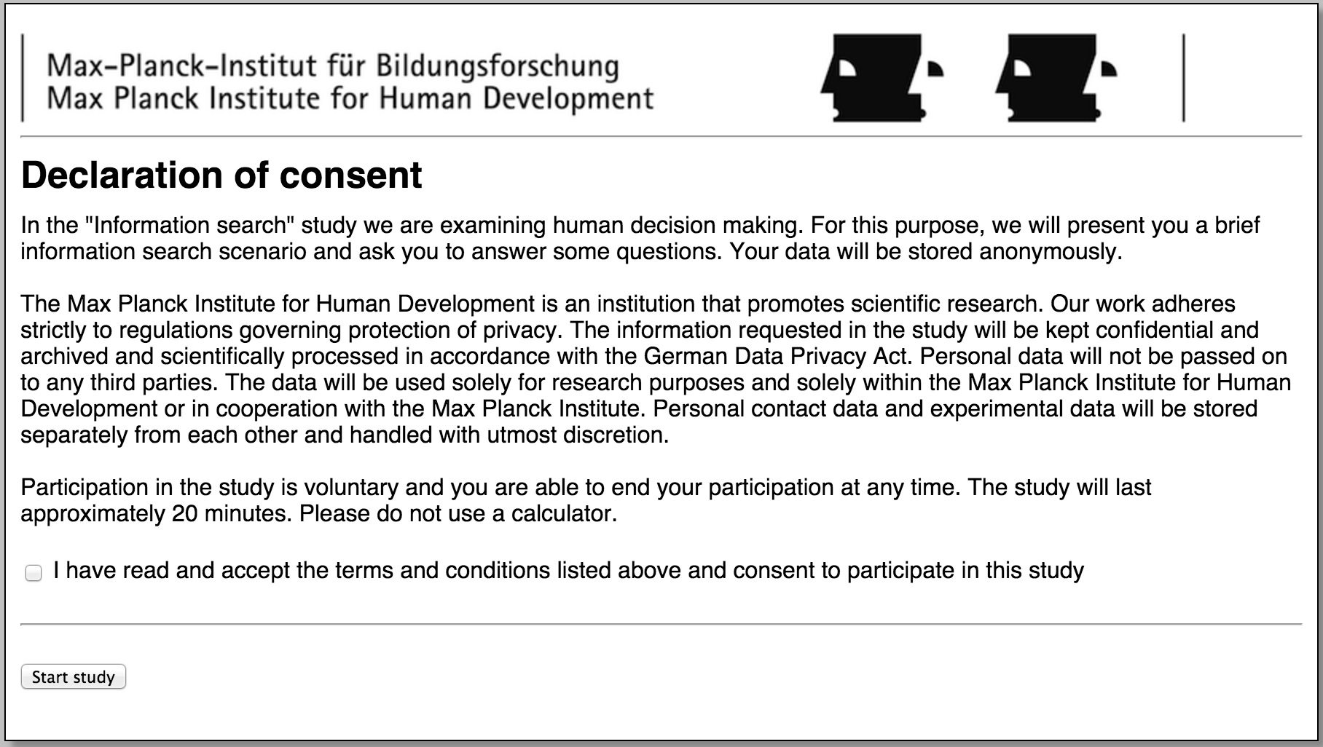

*Figure S2.* Introduction

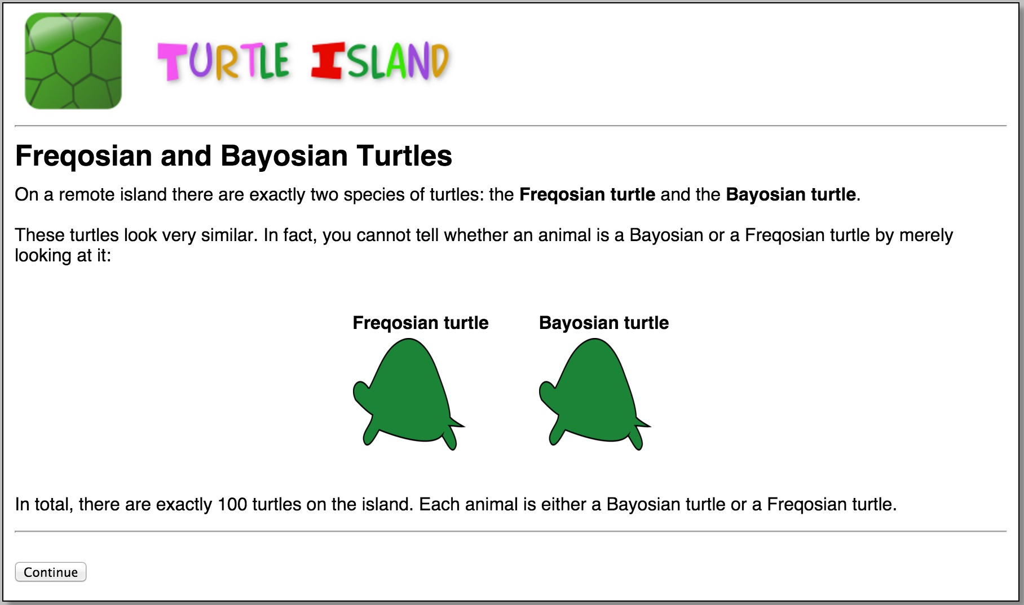

*Figure S3.* Explanation of the DNA tests.

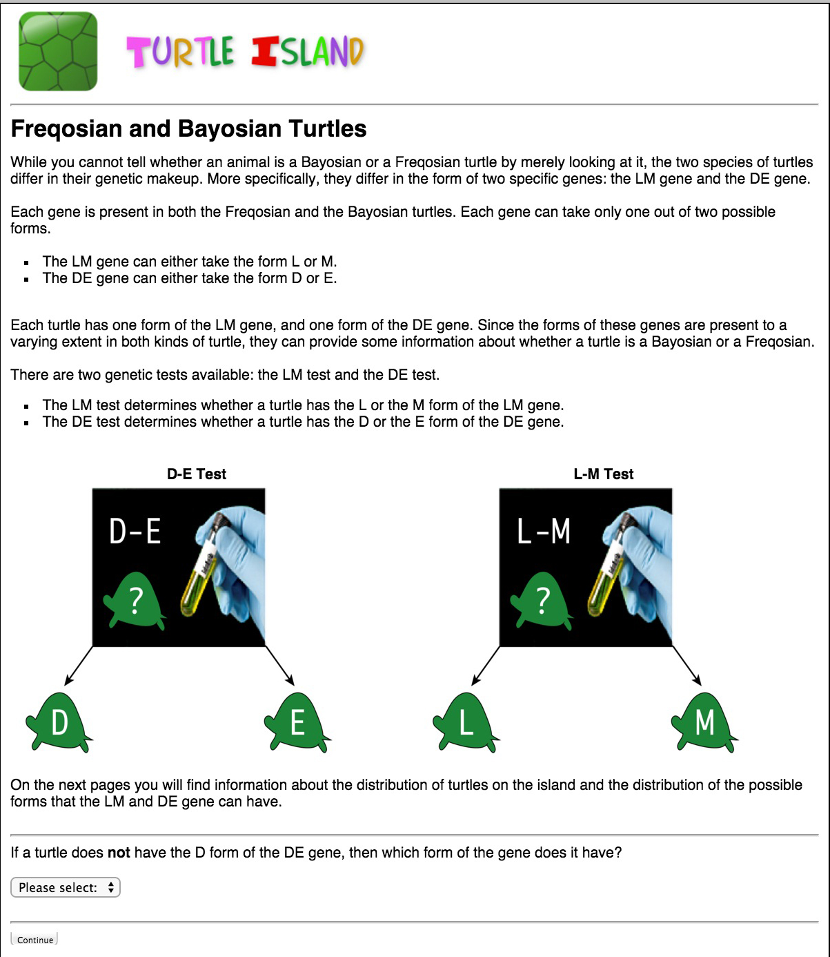

*Figure S4.* Base rate and marginal questions.

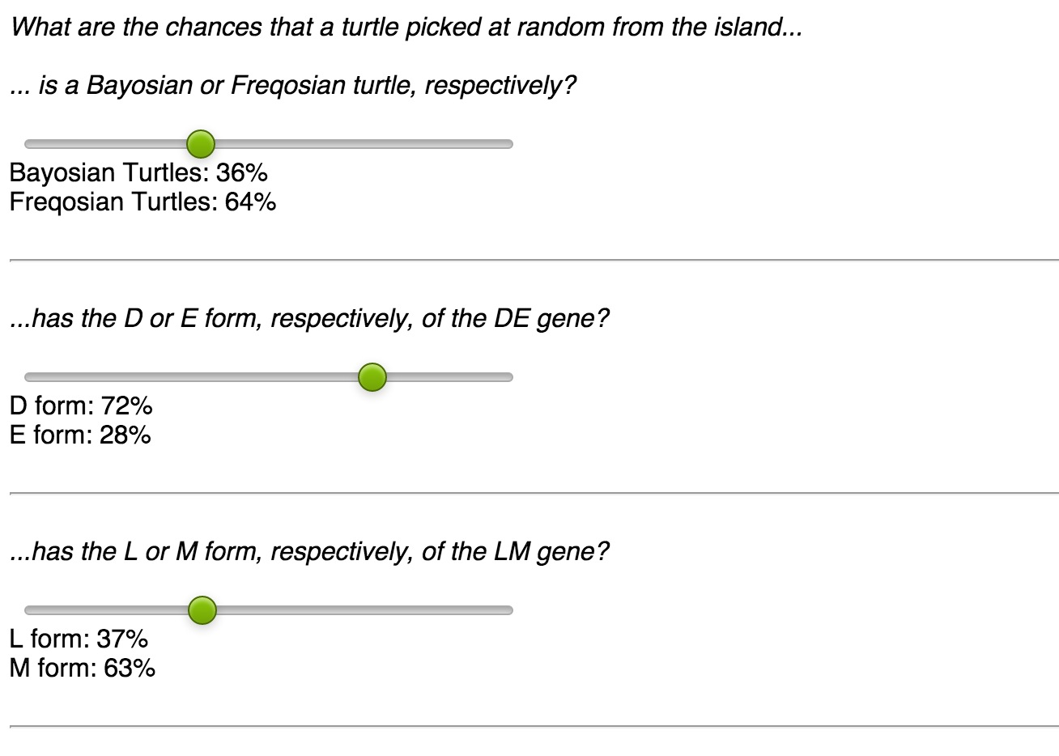

*Figure S5.* Likelihood questions.

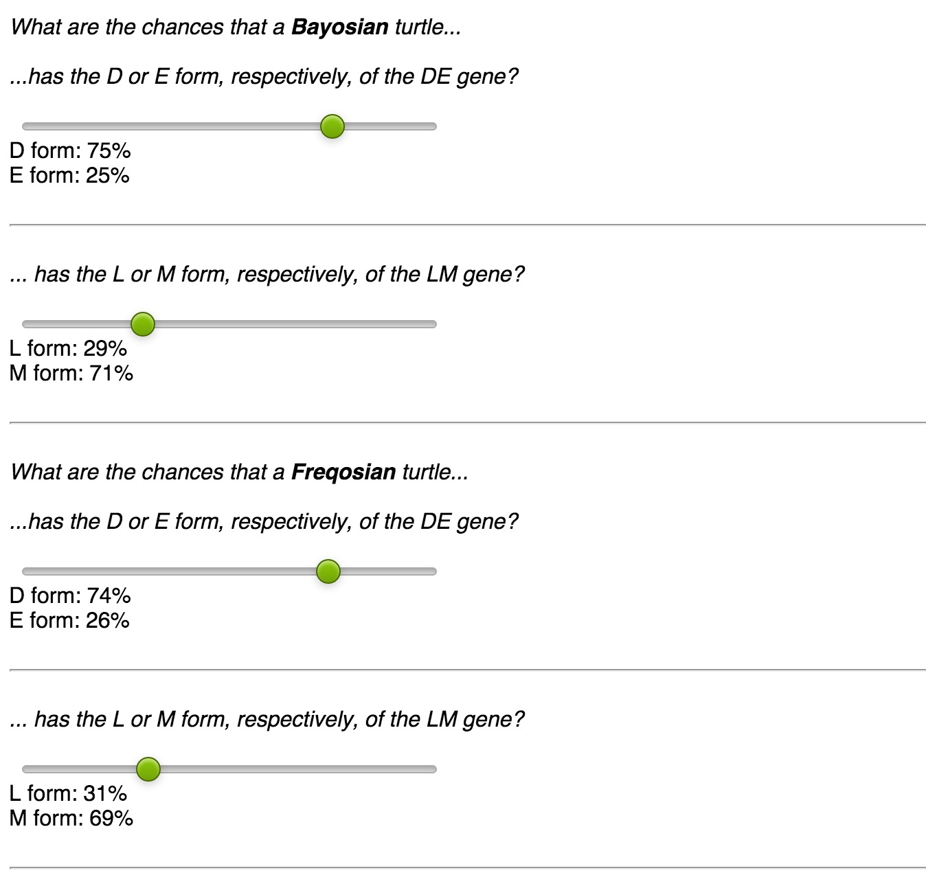

*Figure S6.* Posterior questions.

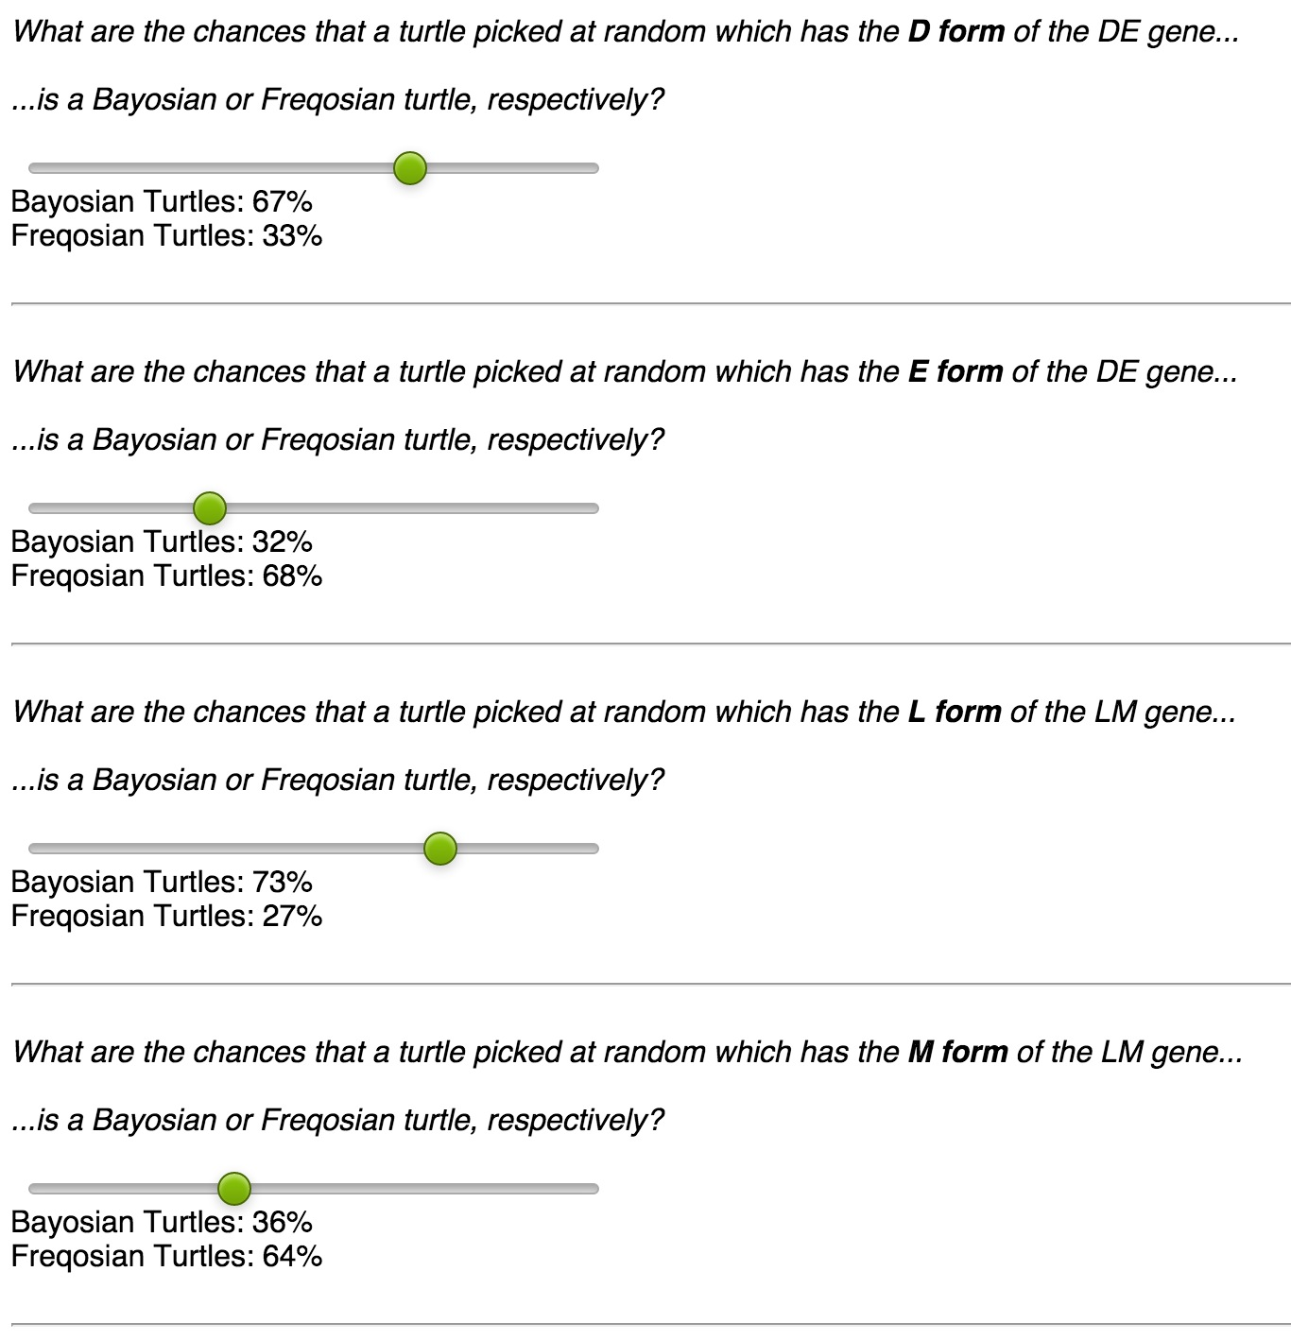

Table S1. *Experiment 1 Presentation Formats*

|  |  |
| --- | --- |
| Format | Information |
| Standard Probability  (ProbLik) | Consider a turtle picked at random from the **100** turtles on the island:  The probability that it is a Bayosian turtle is **70%**.  If a turtle is a Bayosian, then the probability that it has the D form of the DE gene is **3%**.  If a turtle is a Freqosian, then the probability that it has the D form of the DE gene is **30%**.  If a turtle is a Bayosian, then the probability that it has the L form of the LM gene is **41%**.  If a turtle is a Freqosian, then the probability that it has the L form of the LM gene is **93%**. |
| Probability with Complement  (ProbLik+) | Consider a turtle picked at random from the **100** turtles on the island:  The probability that it is a Bayosian turtle is **70%**, and the probability that it is a Freqosian turtle is **30%**.  If a turtle is a Bayosian, then the probability that it has the D form of the DE gene is **3%**, and the probability that it has the E form is **97%**.  If a turtle is a Freqosian, then the probability that it has the D form of the DE gene is **30%**, and the probability that it has the E form is **70%**.  If a turtle is a Bayosian, then the probability that it has the L form of the LM gene is **41%**, and the probability that it has the M form is **59%**.  If a turtle is a Freqosian, then the probability that it has the L form of the LM gene is **93%**, and the probability that it has the M form is **7%**. |
| Posterior Probability  (ProbPost) | Consider a turtle picked at random from the **100** turtles on the island:  The probability that it has the D form of the DE gene is **11%**.  The probability that it has the L form of the LM gene is **57%**.  If a turtle has the D form of the DE gene, then the probability that it is a Bayosian turtle is **19%**.   If a turtle has the E form of the DE gene, then the probability that it is a Bayosian turtle is **76%**.  If a turtle has the L form of the LM gene, then the probability that it is a Bayosian turtle is **51%**.   If a turtle has the M form of the LM gene, then the probability that it is a Bayosian turtle is **95%**. |
| Posterior Probability with Complement  (ProbPost+) | Consider a turtle picked at random from the **100** turtles on the island: The probability that it has the D form of the DE gene is **11%**, and the probability that it has the E form is **89%**.  The probability that it has the L form of the LM gene is **57%**, and the probability that it has the M form is **43%**.  If a turtle has the D form of the DE gene, then the probability that it is a Bayosian turtle is **19%**, and the probability that it is a Freqosian turtle is **81%**.  If a turtle has the E form of the DE gene, then the probability that it is a Bayosian turtle is **76%**, and the probability that it is a Freqosian turtle is **24%**.  If a turtle has the L form of the LM gene, then the probability that it is a Bayosian turtle is **51%**, and the probability that it is a Freqosian turtle is **49%**.  If a turtle has the M form of the LM gene, then the probability that it is a Bayosian turtle is **95%**, and the probability that it is a Freqosian turtle is **5%**. |
| Natural Frequency  (FreqLik) | Out of the **100** turtles on the island, **70** are Bayosian turtles.   Out of the **70** Bayosian turtles, **2** turtles have the D form of the DE gene. Out of the **30** Freqosian turtles, **9** turtles have the D form of the DE gene.  Out of the **70** Bayosian turtles, **29** turtles have the L form of the LM gene. Out of the **30** Freqosian turtles, **28** turtles have the L form of the LM gene. |
| Natural Frequency with Complement  (FreqLik+) | Out of the **100** turtles on the island, **70** are Bayosian turtles and **30** are Freqosian turtles.  Out of the **70** Bayosian turtles, **2** turtles have the D form of the DE gene, and **68** turtles have the E form of the gene. Out of the **30** Freqosian turtles, **9** turtles have the D form of the DE gene, and **21** turtles have the E form of the gene.  Out of the **70** Bayosian turtles, **29** turtles have the L form of the LM gene, and **41** turtles have the M form of the gene. Out of the **30** Freqosian turtles, **28** turtles have the L form of the LM gene, and **2** turtles have the M form of the gene. |
| Posterior Frequency  (FreqPost) | Out of the **100** turtles on the island, **11** have the D form of the DE gene. Out of the **100** turtles on the island, **57** have the L form of the LM gene.  Out of the **11** turtles with the D form of the DE gene, **2** are Bayosian turtles.  Out of the **89** turtles with the E form of the DE gene, **68** are Bayosian turtles.  Out of the **57** turtles with the L form of the LM gene, **29** are Bayosian turtles. Out of the **43** turtles with the M form of the LM gene, **41** are Bayosian turtles. |
| Posterior Frequency with Complement  (FreqPost+) | Out of the **100** turtles on the island, **11** have the D form of the DE gene, and **89** turtles have the E form of the gene.  Out of the **100** turtles on the island, **57** have the L form of the LM gene, and **43** turtles have the M form of the gene.  Out of the **11** turtles with the D form of the DE gene, **2** are Bayosian turtles and **9** are Freqosian turtles.   Out of the **89** turtles with the E form of the DE gene, **68** are Bayosian turtles and **21** are Freqosian turtles.  Out of the **57** turtles with the L form of the LM gene, **29** are Bayosian turtles and **28** are Freqosian turtles.  Out of the **43** turtles with the M form of the LM gene, **41** are Bayosian turtles and **2** are Freqosian turtles. |
| Icon Array  (IconLik) | Below you see a graphical representation of the distribution of the DE gene and the LM gene in Bayosian and Freqosian turtles. Each icon represents **1** out of the total **100** turtles on the island. Macintosh HD:Users:charleywu:Google Drive:(MEi) Notes and Assignments :Masters thesis:Latex files:images:Appendix:Exp2:IconArray.jpg |
| Posterior Icon Array  (IconPost) | Below you see a graphical representation of the distribution of Bayosian and Freqosian turtles for the DE gene and the LM gene. Each icon represents **1** out of the total **100** turtles on the island.Macintosh HD:Users:charleywu:Google Drive:(MEi) Notes and Assignments :Masters thesis:Latex files:images:Appendix:Exp2:PostIconArray.jpg |
| Bar Graph  (BarLik) | Below you see a graphical representation of the distribution of the DE gene and the LM gene in Bayosian and Freqosian turtles. The length of each bar (relative to the span of the white space on the page) indicates the proportion of the total **100** turtles on the island. Macintosh HD:Users:charleywu:Google Drive:(MEi) Notes and Assignments :Masters thesis:Latex files:images:Appendix:Exp1:PostBarGraph.jpg |
| Posterior Bar Graph  (BarPost) | Below you see a graphical representation of the distribution of Bayosian and Freqosian turtles for the DE gene and the LM gene. The length of each bar (relative to the span of the white space on the page) indicates the proportion of the total **100** turtles on the island.  Macintosh HD:Users:charleywu:Google Drive:(MEi) Notes and Assignments :Masters thesis:Latex files:images:Appendix:Exp2:PostBarGraph.jpg |
| Dot Diagram  (DotLik) | Below you see a graphical representation of the distribution of the DE gene and the LM gene in Bayosian and Freqosian turtles. Each dot represents **1** out of the total **100** turtles on the island.Macintosh HD:Users:charleywu:Google Drive:(MEi) Notes and Assignments :Masters thesis:Latex files:images:Appendix:Exp2:DotDiagram.pdf |
| Posterior Dot Diagram  (DotPost) | Below you see a graphical representation of the distribution of Bayosian and Freqosian turtles for the DE gene and the LM gene. Each dot represents **1** out of the total **100** turtles on the island.Macintosh HD:Users:charleywu:Google Drive:(MEi) Notes and Assignments :Masters thesis:Latex files:images:Appendix:Exp2:PostDotDiagram.pdf |
| *Note*. The short name for each format is provided in brackets below the full name, where “Lik” denotes the likelihood variations, the “Post” denotes the posterior variation, and “+” denotes the variation including complement information. | |

Table S2. *Experiment 2 Presentation Formats*

|  |  |
| --- | --- |
| Format | Information |
| Standard Probability  (ProbLik) | Consider a turtle picked at random from the **100** turtles on the island:  The probability that it is a Bayosian turtle is **70%**.  If a turtle is a Bayosian, then the probability that it has the D form of the DE gene is **4%**.  If a turtle is a Freqosian, then the probability that it has the D form of the DE gene is **37%**.  If a turtle is a Bayosian, then the probability that it has the L form of the LM gene is **43%**.  If a turtle is a Freqosian, then the probability that it has the L form of the LM gene is **100%**. |
| Probability with Complement  (ProbLik+) | Consider a turtle picked at random from the **100** turtles on the island:  The probability that it is a Bayosian turtle is **70%**, and the probability that it is a Freqosian turtle is **30%**.  If a turtle is a Bayosian, then the probability that it has the D form of the DE gene is **4%**, and the probability that it has the E form is **96%**.  If a turtle is a Freqosian, then the probability that it has the D form of the DE gene is **37%**, and the probability that it has the E form is **63%**.  If a turtle is a Bayosian, then the probability that it has the L form of the LM gene is **43%**, and the probability that it has the M form is **57%**.  If a turtle is a Freqosian, then the probability that it has the L form of the LM gene is **100%**, and the probability that it has the M form is **0%**. |
| Posterior Probability  (ProbPost) | Consider a turtle picked at random from the **100** turtles on the island:  The probability that it has the D form of the DE gene is **14%**.  The probability that it has the L form of the LM gene is **60%**.  If a turtle has the D form of the DE gene, then the probability that it is a Bayosian turtle is **20%**.   If a turtle has the E form of the DE gene, then the probability that it is a Bayosian turtle is **78%**.  If a turtle has the L form of the LM gene, then the probability that it is a Bayosian turtle is **50%**.   If a turtle has the M form of the LM gene, then the probability that it is a Bayosian turtle is **100%**. |
| Posterior Probability with Complement  (ProbPost+) | Consider a turtle picked at random from the **100** turtles on the island: The probability that it has the D form of the DE gene is **14%**, and the probability that it has the E form is **86%**.  The probability that it has the L form of the LM gene is **60%**, and the probability that it has the M form is **40%**.  If a turtle has the D form of the DE gene, then the probability that it is a Bayosian turtle is **20%**, and the probability that it is a Freqosian turtle is **80%**.  If a turtle has the E form of the DE gene, then the probability that it is a Bayosian turtle is **78%**, and the probability that it is a Freqosian turtle is **22%**.  If a turtle has the L form of the LM gene, then the probability that it is a Bayosian turtle is **50%**, and the probability that it is a Freqosian turtle is **50%**.  If a turtle has the M form of the LM gene, then the probability that it is a Bayosian turtle is **100%**, and the probability that it is a Freqosian turtle is **0%**. |
| Natural Frequency  (FreqLik) | Out of the **100** turtles on the island, **70** are Bayosian turtles.   Out of the **70** Bayosian turtles, **3** turtles have the D form of the DE gene. Out of the **30** Freqosian turtles, **11** turtles have the D form of the DE gene.  Out of the **70** Bayosian turtles, **30** turtles have the L form of the LM gene. Out of the **30** Freqosian turtles, **30** turtles have the L form of the LM gene. |
| Natural Frequency with Complement  (FreqLik+) | Out of the **100** turtles on the island, **70** are Bayosian turtles and **30** are Freqosian turtles.  Out of the **70** Bayosian turtles, **3** turtles have the D form of the DE gene, and **67** turtles have the E form of the gene. Out of the **30** Freqosian turtles, **11** turtles have the D form of the DE gene, and **19** turtles have the E form of the gene.  Out of the **70** Bayosian turtles, **30** turtles have the L form of the LM gene, and **40** turtles have the M form of the gene. Out of the **30** Freqosian turtles, **30** turtles have the L form of the LM gene, and **0** turtles have the M form of the gene. |
| Posterior Frequency  (FreqPost) | Out of the **100** turtles on the island, **14** have the D form of the DE gene. Out of the **100** turtles on the island, **60** have the L form of the LM gene.  Out of the **14** turtles with the D form of the DE gene, **3** are Bayosian turtles.  Out of the **86** turtles with the E form of the DE gene, **67** are Bayosian turtles.  Out of the **60** turtles with the L form of the LM gene, **30** are Bayosian turtles. Out of the **40** turtles with the M form of the LM gene, **40** are Bayosian turtles. |
| Posterior Frequency with Complement  (FreqPost+) | Out of the **100** turtles on the island, **14** have the D form of the DE gene, and **86** turtles have the E form of the gene.  Out of the **100** turtles on the island, **60** have the L form of the LM gene, and **40** turtles have the M form of the gene.  Out of the **14** turtles with the D form of the DE gene, **3** are Bayosian turtles and **11** are Freqosian turtles.   Out of the **86** turtles with the E form of the DE gene, **67** are Bayosian turtles and **19** are Freqosian turtles.  Out of the **60** turtles with the L form of the LM gene, **30** are Bayosian turtles and **30** are Freqosian turtles.  Out of the **40** turtles with the M form of the LM gene, **40** are Bayosian turtles and **0** are Freqosian turtles. |
| Icon Array  (IconLik) | Below you see a graphical representation of the distribution of the DE gene and the LM gene in Bayosian and Freqosian turtles. Each icon represents **1** out of the total **100** turtles on the island. Macintosh HD:Users:charleywu:Google Drive:(MEi) Notes and Assignments :Masters thesis:Latex files:images:Appendix:Exp3:IconArray.jpg |
| Posterior Icon Array  (IconPost) | Below you see a graphical representation of the distribution of Bayosian and Freqosian turtles for the DE gene and the LM gene. Each icon represents **1** out of the total **100** turtles on the island.Macintosh HD:Users:charleywu:Google Drive:(MEi) Notes and Assignments :Masters thesis:Latex files:images:Appendix:Exp3:PostIconArray.jpg |
| Bar Graph  (BarLik) | Below you see a graphical representation of the distribution of the DE gene and the LM gene in Bayosian and Freqosian turtles. The length of each bar (relative to the span of the white space on the page) indicates the proportion of the total **100** turtles on the island. Macintosh HD:Users:charleywu:Google Drive:(MEi) Notes and Assignments :Masters thesis:Latex files:images:Appendix:Exp3:BarGraph.jpg |
| Posterior Bar Graph  (BarPost) | Below you see a graphical representation of the distribution of Bayosian and Freqosian turtles for the DE gene and the LM gene. The length of each bar (relative to the span of the white space on the page) indicates the proportion of the total **100** turtles on the island.Macintosh HD:Users:charleywu:Google Drive:(MEi) Notes and Assignments :Masters thesis:Latex files:images:Appendix:Exp3:PostBarGraph.jpg |
| Dot Diagram  (DotLik) | Below you see a graphical representation of the distribution of the DE gene and the LM gene in Bayosian and Freqosian turtles. Each dot represents **1** out of the total **100** turtles on the island.  Macintosh HD:Users:charleywu:Google Drive:(MEi) Notes and Assignments :Masters thesis:Latex files:images:Appendix:Exp3:DotDiagram.pdf |
| Posterior Dot Diagram  (DotPost) | Below you see a graphical representation of the distribution of Bayosian and Freqosian turtles for the DE gene and the LM gene. Each dot represents **1** out of the total **100** turtles on the island.Macintosh HD:Users:charleywu:Google Drive:(MEi) Notes and Assignments :Masters thesis:Latex files:images:Appendix:Exp3:PostDotDiagram.pdf |
| *Note*. The short name for each format is provided in brackets below the full name, where “Lik” denotes the likelihood variations, the “Post” denotes the posterior variation, and “+” denotes the variation including complement information. | |

Table S3. *Experiment 3 Presentation Formats*

|  |  |
| --- | --- |
| Format | Information |
| Standard Probability  (ProbLik) | Consider a turtle picked at random from the **100** turtles on the island:  The probability that it is a Bayosian turtle is **72%**.  If a turtle is a Bayosian, then the probability that it has the D form of the DE gene is **3%**.  If a turtle is a Freqosian, then the probability that it has the D form of the DE gene is **83%**.  If a turtle is a Bayosian, then the probability that it has the L form of the LM gene is **39%**.  If a turtle is a Freqosian, then the probability that it has the L form of the LM gene is **100%**. |
| Probability with Complement  (ProbLik+) | Consider a turtle picked at random from the **100** turtles on the island:  The probability that it is a Bayosian turtle is **72%**, and the probability that it is a Freqosian turtle is **28%**.  If a turtle is a Bayosian, then the probability that it has the D form of the DE gene is **3%**, and the probability that it has the E form is **97%**.  If a turtle is a Freqosian, then the probability that it has the D form of the DE gene is **83%**, and the probability that it has the E form is **17%**.  If a turtle is a Bayosian, then the probability that it has the L form of the LM gene is **39%**, and the probability that it has the M form is **61%**.  If a turtle is a Freqosian, then the probability that it has the L form of the LM gene is **100%**, and the probability that it has the M form is **0%**. |
| Posterior Probability  (ProbPost) | Consider a turtle picked at random from the **100** turtles on the island:  The probability that it has the D form of the DE gene is **25%**.  The probability that it has the L form of the LM gene is **56%**.  If a turtle has the D form of the DE gene, then the probability that it is a Bayosian turtle is **9%**.   If a turtle has the E form of the DE gene, then the probability that it is a Bayosian turtle is **94%**.  If a turtle has the L form of the LM gene, then the probability that it is a Bayosian turtle is **50%**.   If a turtle has the M form of the LM gene, then the probability that it is a Bayosian turtle is **100%**. |
| Posterior Probability with Complement  (ProbPost+) | Consider a turtle picked at random from the **100** turtles on the island: The probability that it has the D form of the DE gene is **25%**, and the probability that it has the E form is **75%**.  The probability that it has the L form of the LM gene is **56%**, and the probability that it has the M form is **44%**.  If a turtle has the D form of the DE gene, then the probability that it is a Bayosian turtle is **9%**, and the probability that it is a Freqosian turtle is **91%**.  If a turtle has the E form of the DE gene, then the probability that it is a Bayosian turtle is **94%**, and the probability that it is a Freqosian turtle is **6%**.  If a turtle has the L form of the LM gene, then the probability that it is a Bayosian turtle is **50%**, and the probability that it is a Freqosian turtle is **50%**.  If a turtle has the M form of the LM gene, then the probability that it is a Bayosian turtle is **100%**, and the probability that it is a Freqosian turtle is **0%**. |
| Natural Frequency  (FreqLik) | Out of the **100** turtles on the island, **72** are Bayosian turtles.   Out of the **72** Bayosian turtles, **2** turtles have the D form of the DE gene. Out of the **28** Freqosian turtles, **23** turtles have the D form of the DE gene.  Out of the **72** Bayosian turtles, **28** turtles have the L form of the LM gene. Out of the **28** Freqosian turtles, **28** turtles have the L form of the LM gene. |
| Natural Frequency with Complement  (FreqLik+) | Out of the **100** turtles on the island, **72** are Bayosian turtles and **28** are Freqosian turtles.  Out of the **72** Bayosian turtles, **2** turtles have the D form of the DE gene, and **70** turtles have the E form of the gene. Out of the **28** Freqosian turtles, **23** turtles have the D form of the DE gene, and **5** turtles have the E form of the gene.  Out of the **72** Bayosian turtles, **28** turtles have the L form of the LM gene, and **44** turtles have the M form of the gene. Out of the **28** Freqosian turtles, **28** turtles have the L form of the LM gene, and **0** turtles have the M form of the gene. |
| Posterior Frequency  (FreqPost) | Out of the **100** turtles on the island, **25** have the D form of the DE gene. Out of the **100** turtles on the island, **56** have the L form of the LM gene.  Out of the **25** turtles with the D form of the DE gene, **2** are Bayosian turtles.  Out of the **75** turtles with the E form of the DE gene, **70** are Bayosian turtles.  Out of the **56** turtles with the L form of the LM gene, **28** are Bayosian turtles. Out of the **44** turtles with the M form of the LM gene, **44** are Bayosian turtles. |
| Posterior Frequency with Complement  (FreqPost+) | Out of the **100** turtles on the island, **25** have the D form of the DE gene, and **75** turtles have the E form of the gene.  Out of the **100** turtles on the island, **56** have the L form of the LM gene, and **44** turtles have the M form of the gene.  Out of the **25** turtles with the D form of the DE gene, **2** are Bayosian turtles and **23** are Freqosian turtles.   Out of the **75** turtles with the E form of the DE gene, **70** are Bayosian turtles and **5** are Freqosian turtles.  Out of the **56** turtles with the L form of the LM gene, **28** are Bayosian turtles and **28** are Freqosian turtles.  Out of the **44** turtles with the M form of the LM gene, **44** are Bayosian turtles and **0** are Freqosian turtles. |
| Icon Array  (IconLik) | Below you see a graphical representation of the distribution of the DE gene and the LM gene in Bayosian and Freqosian turtles. Each icon represents **1** out of the total **100** turtles on the island. Macintosh HD:Users:charleywu:Google Drive:(MEi) Notes and Assignments :Masters thesis:Latex files:images:Appendix:Exp4:IconArray.jpg |
| Posterior Icon Array  (IconPost) | Below you see a graphical representation of the distribution of Bayosian and Freqosian turtles for the DE gene and the LM gene. Each icon represents **1** out of the total **100** turtles on the island.Macintosh HD:Users:charleywu:Google Drive:(MEi) Notes and Assignments :Masters thesis:Latex files:images:Appendix:Exp4:PostIconArray.jpg |
| Bar Graph  (BarLik) | Below you see a graphical representation of the distribution of the DE gene and the LM gene in Bayosian and Freqosian turtles. The length of each bar (relative to the span of the white space on the page) indicates the proportion of the total **100** turtles on the island. Macintosh HD:Users:charleywu:Google Drive:(MEi) Notes and Assignments :Masters thesis:Latex files:images:Appendix:Exp4:BarGraph.jpg |
| Posterior Bar Graph  (BarPost) | Below you see a graphical representation of the distribution of Bayosian and Freqosian turtles for the DE gene and the LM gene. The length of each bar (relative to the span of the white space on the page) indicates the proportion of the total **100** turtles on the island.Macintosh HD:Users:charleywu:Google Drive:(MEi) Notes and Assignments :Masters thesis:Latex files:images:Appendix:Exp4:PostBarGraph.jpg |
| Dot Diagram  (DotLik) | Below you see a graphical representation of the distribution of the DE gene and the LM gene in Bayosian and Freqosian turtles. Each dot represents **1** out of the total **100** turtles on the island.  Macintosh HD:Users:charleywu:Google Drive:(MEi) Notes and Assignments :Masters thesis:Latex files:images:Appendix:Exp4:DotDiagram.pdf |
| Posterior Dot Diagram  (DotPost) | Below you see a graphical representation of the distribution of Bayosian and Freqosian turtles for the DE gene and the LM gene. Each dot represents **1** out of the total **100** turtles on the island.Macintosh HD:Users:charleywu:Google Drive:(MEi) Notes and Assignments :Masters thesis:Latex files:images:Appendix:Exp4:PostDotDiagram.pdf |
| *Note*. The short name for each format is provided in brackets below the full name, where “Lik” denotes the likelihood variations, the “Post” denotes the posterior variation, and “+” denotes the variation including complement information. | |

Table S4. *Experiment 4 Presentation Formats*

|  |  |
| --- | --- |
| Format | Information |
| Standard Probability  (ProbLik) | Consider a turtle picked at random from the **100** turtles on the island:  The probability that it is a Bayosian turtle is **50%**.  If a turtle is a Bayosian, then the probability that it has the D form of the DE gene is **10%**.  If a turtle is a Freqosian, then the probability that it has the D form of the DE gene is **80%**.  If a turtle is a Bayosian, then the probability that it has the L form of the LM gene is **10%**.  If a turtle is a Freqosian, then the probability that it has the L form of the LM gene is **30%**. |
| Probability with Complement  (ProbLik+) | Consider a turtle picked at random from the **100** turtles on the island:  The probability that it is a Bayosian turtle is **50%**, and the probability that it is a Freqosian turtle is **50%**.  If a turtle is a Bayosian, then the probability that it has the D form of the DE gene is **10%**, and the probability that it has the E form is **90%**.  If a turtle is a Freqosian, then the probability that it has the D form of the DE gene is **80%**, and the probability that it has the E form is **20%**.  If a turtle is a Bayosian, then the probability that it has the L form of the LM gene is **10%**, and the probability that it has the M form is **90%**.  If a turtle is a Freqosian, then the probability that it has the L form of the LM gene is **30%**, and the probability that it has the M form is **70%**. |
| Posterior Probability  (ProbPost) | Consider a turtle picked at random from the **100** turtles on the island:  The probability that it has the D form of the DE gene is **45%**.  The probability that it has the L form of the LM gene is **20%**.  If a turtle has the D form of the DE gene, then the probability that it is a Bayosian turtle is **11%**.   If a turtle has the E form of the DE gene, then the probability that it is a Bayosian turtle is **82%**.  If a turtle has the L form of the LM gene, then the probability that it is a Bayosian turtle is **25%**.   If a turtle has the M form of the LM gene, then the probability that it is a Bayosian turtle is **56%**. |
| Posterior Probability with Complement  (ProbPost+) | Consider a turtle picked at random from the **100** turtles on the island: The probability that it has the D form of the DE gene is **45%**, and the probability that it has the E form is **55%**.  The probability that it has the L form of the LM gene is **20%**, and the probability that it has the M form is **80%**.  If a turtle has the D form of the DE gene, then the probability that it is a Bayosian turtle is **11%**, and the probability that it is a Freqosian turtle is **89%**.  If a turtle has the E form of the DE gene, then the probability that it is a Bayosian turtle is **82%**, and the probability that it is a Freqosian turtle is **18%**.  If a turtle has the L form of the LM gene, then the probability that it is a Bayosian turtle is **25%**, and the probability that it is a Freqosian turtle is **75%**.  If a turtle has the M form of the LM gene, then the probability that it is a Bayosian turtle is **56%**, and the probability that it is a Freqosian turtle is **44%**. |
| Natural Frequency  (FreqLik) | Out of the **100** turtles on the island, **50** are Bayosian turtles.   Out of the **50** Bayosian turtles, **5** turtles have the D form of the DE gene. Out of the **50** Freqosian turtles, **40** turtles have the D form of the DE gene.  Out of the **50** Bayosian turtles, **5** turtles have the L form of the LM gene. Out of the **50** Freqosian turtles, **15** turtles have the L form of the LM gene. |
| Natural Frequency with Complement  (FreqLik+) | Out of the **100** turtles on the island, **50** are Bayosian turtles and **50** are Freqosian turtles.  Out of the **50** Bayosian turtles, **5** turtles have the D form of the DE gene, and **45** turtles have the E form of the gene. Out of the **50** Freqosian turtles, **40** turtles have the D form of the DE gene, and **10** turtles have the E form of the gene.  Out of the **50** Bayosian turtles, **5** turtles have the L form of the LM gene, and **45** turtles have the M form of the gene. Out of the **50** Freqosian turtles, **15** turtles have the L form of the LM gene, and **35** turtles have the M form of the gene. |
| Posterior Frequency  (FreqPost) | Out of the **100** turtles on the island, **45** have the D form of the DE gene. Out of the **100** turtles on the island, **20** have the L form of the LM gene.  Out of the **45** turtles with the D form of the DE gene, **5** are Bayosian turtles.  Out of the **55** turtles with the E form of the DE gene, **45** are Bayosian turtles.  Out of the **20** turtles with the L form of the LM gene, **5** are Bayosian turtles. Out of the **80** turtles with the M form of the LM gene, **45** are Bayosian turtles. |
| Posterior Frequency with Complement  (FreqPost+) | Out of the **100** turtles on the island, **45** have the D form of the DE gene, and **55** turtles have the E form of the gene.  Out of the **100** turtles on the island, **20** have the L form of the LM gene, and **80** turtles have the M form of the gene.  Out of the **45** turtles with the D form of the DE gene, **5** are Bayosian turtles and **40** are Freqosian turtles.   Out of the **55** turtles with the E form of the DE gene, **45** are Bayosian turtles and **10** are Freqosian turtles.  Out of the **20** turtles with the L form of the LM gene, **5** are Bayosian turtles and **15** are Freqosian turtles.  Out of the **80** turtles with the M form of the LM gene, **45** are Bayosian turtles and **35** are Freqosian turtles. |
| Icon Array  (IconLik) | Below you see a graphical representation of the distribution of the DE gene and the LM gene in Bayosian and Freqosian turtles. Each icon represents **1** out of the total **100** turtles on the island.  Macintosh HD:Users:charleywu:Google Drive:(MEi) Notes and Assignments :Masters thesis:Latex files:images:Appendix:Exp1:IconArray.jpg |
| Posterior Icon Array  (IconPost) | Below you see a graphical representation of the distribution of Bayosian and Freqosian turtles for the DE gene and the LM gene. Each icon represents **1** out of the total **100** turtles on the island.  Macintosh HD:Users:charleywu:Google Drive:(MEi) Notes and Assignments :Masters thesis:Latex files:images:Appendix:Exp1:PostIconArray.jpg |
| Bar Graph  (BarLik) | Below you see a graphical representation of the distribution of the DE gene and the LM gene in Bayosian and Freqosian turtles. The length of each bar (relative to the span of the white space on the page) indicates the proportion of the total **100** turtles on the island.  Macintosh HD:Users:charleywu:Google Drive:(MEi) Notes and Assignments :Masters thesis:Latex files:images:Appendix:Exp1:BarGraph.jpg |
| Posterior Bar Graph  (BarPost) | Below you see a graphical representation of the distribution of Bayosian and Freqosian turtles for the DE gene and the LM gene. The length of each bar (relative to the span of the white space on the page) indicates the proportion of the total **100** turtles on the island.  Macintosh HD:Users:charleywu:Google Drive:(MEi) Notes and Assignments :Masters thesis:Latex files:images:Appendix:Exp1:PostBarGraph.jpg |
| Dot Diagram  (DotLik) | Below you see a graphical representation of the distribution of the DE gene and the LM gene in Bayosian and Freqosian turtles. Each dot represents **1** out of the total **100** turtles on the island.  Macintosh HD:Users:charleywu:Google Drive:(MEi) Notes and Assignments :Masters thesis:Latex files:images:Appendix:Exp1:DotDiagram.pdf |
| Posterior Dot Diagram  (DotPost) | Below you see a graphical representation of the distribution of Bayosian and Freqosian turtles for the DE gene and the LM gene. Each dot represents **1** out of the total **100** turtles on the island.Macintosh HD:Users:charleywu:Google Drive:(MEi) Notes and Assignments :Masters thesis:Latex files:images:Appendix:Exp1:PostDotDiagram.pdf |
| *Note*. The short name for each format is provided in brackets below the full name, where “Lik” denotes the likelihood variations, the “Post” denotes the posterior variation, and “+” denotes the variation including complement information. | |