**EXPERIMENT 1**

**N170 Results: Old/New Recognition task**

**Peak Latency**. In the recognition phase the 2 x 2 repeated measure ANOVA revealed no significant interaction between *Face Type* and *Orientation*, *F*(1,28) = .117, p = .667. A simple effect analysis showed a significant inversion effect on latencies to inverted normal faces (*M* = 168 ms, *SE* = 3.76) which were significantly delayed compared to latencies for upright normal faces (*M* = 162 ms, *SE* = 3.97), *t*(28) = 4.045, SE = 1.29, *p* < .001, η2p = .36. A significant inversion effect was also found between upright (*M* = 165 ms, *SE* = 4.61) and inverted (*M* = 169 ms, *SE* = 3.79) Thatcherised faces, *t*(28) = 2.574, SE = 1.60, *p* = .016, η2p = .19. No significant difference was found between normal upright faces vs Thatcherised upright faces *t*(28) = 1.507, *p* = .143 (see Figure attached below).

**Peak Amplitude.** A 2 x 2 repeated measure ANOVA revealed no significant interaction, *F*(1,23) = .009, p = .925. A planned comparison showed a not significant inversion effect for inverted normal faces (*M* = -.728μV, *SE* = 0.37) amplitudes compared to upright normal faces (*M* = -.385μV, *SE* = 0.41), *t*(28) = 1.584, *p* = .11. A not significant effect of inversion was recorded for the amplitudes corresponding response to Thatcherised upright (*M* = -.542μV, *SE* = 0.40) vs inverted (*M* = -.907μV, *SE* = 0.45) faces, *t*(28) = 2.144, SE = .170, *p* = .38, η2p = .14. No significant difference was found between normal upright faces vs Thatcherised upright faces *t*(28) = .958, *p* = .346 (see Figure S1).

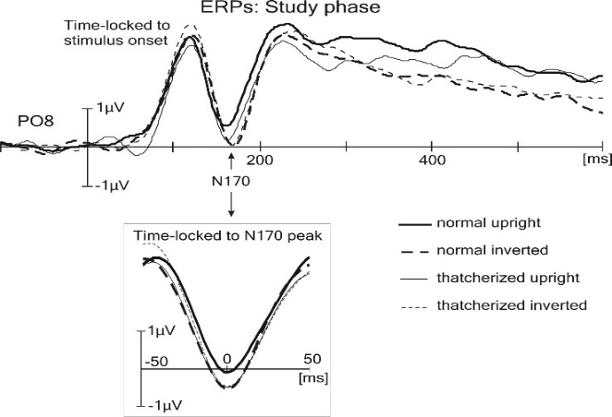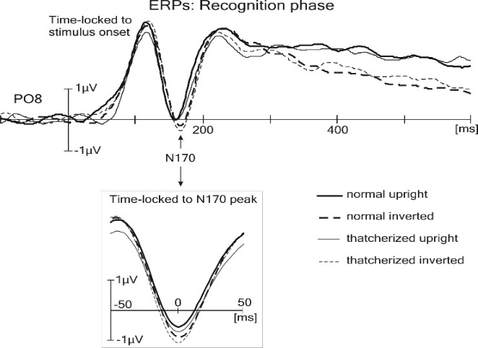

**Figure S1**. Waveforms at electrode P08 for the recognition task. The X-axis shows the elapsed time after a stimulus was presented and the Y-axis shows the ERP amplitudes (μV). The insert in this figure shows the ERPs time-locked to the N170 peak (rather than the stimulus onset), for a clearer representation of ERP amplitude in the different conditions.

**EXPERIMENT 3**

**Experiment 3a and 3b overall results Figure**



**Figure S2.** The results broken down by condition and by sub-experiment for Experiment 3. Top panel Experiment 3a, bottom panel Experiment 3b. Sham conditions are on the left of each figure. The *x*-axis shows the stimulus conditions for each tDCS group. The *y*-axis shows sensitivity d’ measure (0 = 50% accuracy). Error bars represent s.e.m.