Supplementary material
Figure S1
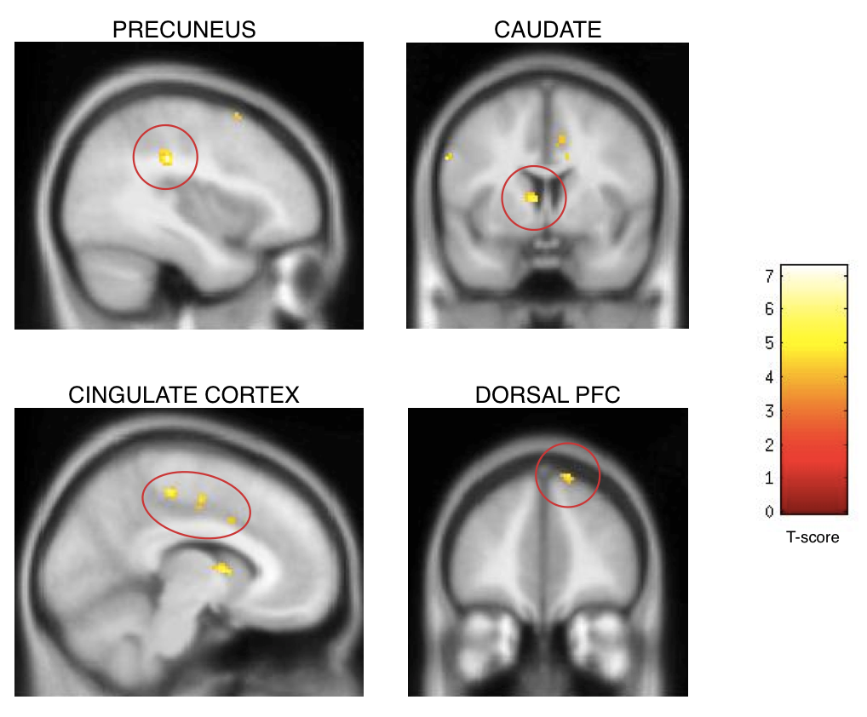
CAPTION
Neural activation at the time of framing demonstrates higher engagement for the competition frame relative to the cooperation frame in a widespread network of brain regions including precuneus (-2, -22, 48, T=6.0, p<0.001 u.c., 115 voxels), caudate nucleus (-8, 4, 6, T=5.7, p<0.001, 39 voxels), cingulate cortex (e.g., 16, -14, 34, T= 6.5, p<0.001, 41 voxels), and dorsal PFC (30, 18, 64, T= 4.5, p<0.001, 7 voxels). Activation is displayed, for illustrative purposes, using an uncorrected statistical threshold of p<0.001 with a cluster extent threshold of 5, heat bar denotes T-values.
Table T1
Probit model with random effects
 | Study 1 |  | Study 2
Dependent variable: Cooperation (=1) or Defection (=0)
Frame (1: cooperation frame, 0: competition frame) | 0.649*** |  | 1.121***
 | (0.0906) |  | (0.0763)
Constant | -0.546*** |  | -0.778***
 | (0.143) |  | (0.226)
Observations | 877 |  | 1,680
Number of individuals | 14 |  | 30
Wald test chi2 | 51.35 |  | 216.0
Wald test probability | 0 |  | 0
Numbers denote coefficient
Standard errors in parentheses
*** p<0.01, ** p<0.05, * p<0.1
Probit model with random effects
 |  | Study 1
Dependent variable: Belief (Cooperation=1 or Defection=0)
Frame (1: cooperation frame, 0: competition frame) |  | 0.401***
 |  | (0.0632)
Constant |  | -0.0124
 |  | (0.0750)
Observations |  | 1,680
Individuals |  | 30
Wald test chi2 |  | 40.13
Wald test probability |  | 0
Numbers denote coefficient
Standard errors in parentheses
*** p<0.01, ** p<0.05, * p<0.1

Table T2 – Neural activation larger for competition frame than cooperation frame during framing phase
Brain region | Hemisphere | Peak coordinates  (x,y,z) | Number of activated voxels | Z-value | p-value
Cingulate Cortex | Right | 16, -14, 34 | 41 | 4.08 | <0.001 u.c.
 | Right | 12, 6, 32 | 5 | 3.34 | <0.001 u.c.
 | Left | -6, 8, 36 | 17 | 3.32 | <0.001 u.c.
Precuneus | Right | -2, -22, 48 | 115 | 3.92 | <0.001 u.c.
Cuneus | Right | -22, -68, 16 | 7 | 3.53 | <0.001 u.c.
Anterior intraparietal sulcus | Right | -38, -30, 32 | 64 | 4.32 | <0.001 u.c.
 | Left | 34, -54, 30 | 42 | 3.73 | <0.001 u.c.
Primary motor cortex | Right | -8, -26, 54 | 113 | 3.79 | <0.001 u.c.
Lateral PFC | Right | -60, 4, 32 | 13 | 3.76 | <0.001 u.c.
Medial PFC | Left | 14, 44, 54 | 22 | 3.58 | <0.001 u.c.
Dorsolateral PFC | Right | -36, 14, 60 | 6 | 3.36 | <0.001 u.c.
 | Left | 30, 18, 64 | 7 | 3.31 | <0.001 u.c.
Temporal cortex | Right | -34, -86, -18 | 16 | 4.03 | <0.001 u.c.
 | Left | 52, -62, 20 | 6 | 3.41 | <0.001 u.c.
Caudate nucleus | Right | -8, 4, 6 | 39 | 3.8 | <0.001 u.c.
 | Right | -16, -4, 16 | 9 | 3.32 | <0.001 u.c.
Thalamus | Left | 16 -20 10 | 9 | 3.51 | <0.001 u.c.
Left lateral occipital cortex | Right | -50, -76, 14 | 18 | 3.83 | <0.001 u.c.
 | Right | -36, -78, 42 | 16 | 3.36 | <0.001 u.c.
Cerebellum | Right | -28 -84 -36 | 11 | 3.79 | <0.001 u.c.

CAPTION
Brain regions showing stronger engagement for the competition cue relative to the cooperation cue during the framing phase. All results refer to the peak-level activation at the time that the framing cue is seen, and modeled with a duration = 0 secs. Abbreviations: PFC = Prefrontal cortex; u.c. = uncorrected (for multiple comparisons)

