Supplementary Materials - Instructions
Information sheet for the Discrimination conditions – Experiment 3
Background information
- During an investigation of a crime, police officers might arrest a suspect (a person they think may have committed the crime).
- It is important for the police to work out whether they have arrested the right person. In other words, the police need to determine whether their suspect is the same person as the perpetrator (the person who actually committed the crime).
- To help determine whether the suspect is the perpetrator, police might ask a witness (a person who saw the crime take place) to view a lineup.
- A lineup contains the suspect and some “fillers”. Fillers are people who are known-to-be innocent (e.g., plain-clothed police or community volunteers) who match the general description of the perpetrator.
- The witness’s response to the lineup can help police to work out if their suspect is actually the perpetrator. There are different procedures for asking the witness to make their response.

The lineup procedure used in this investigation
- In the police investigation of this case, the witness viewed a lineup of 8 photos.
  - One photo was of the suspect in this case.
  - The other 7 photos were of fillers.
- The witness was asked to think about how well each photo in the lineup matched their memory of the perpetrator, and to give each photo a rating (out of 100).
- The witness was instructed that:
  - If a photo is a perfect match to their memory, it should get a rating of 100.
  - If a photo does not match at all their memory, it should get a rating of 0.
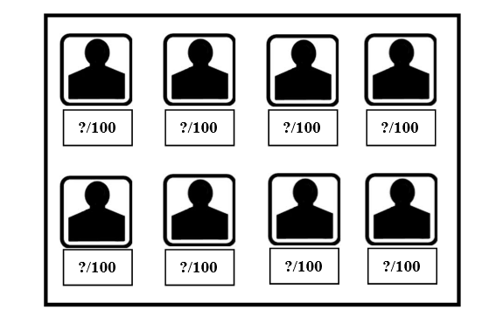
How to interpret the witness’s ratings
- Looking at the pattern of ratings given to the suspect and the fillers tells us something about how likely it is that the suspect is actually the perpetrator.
- There are three things to look for:
(1) Did the suspect get the highest rating of all the photos in the lineup?
  - If not, the suspect is probably not guilty.
(2) How high was the rating given to the suspect?
- The higher the rating given to the suspect, the more likely it is the suspect is guilty.
(3) How high were the ratings given to the fillers?
- The higher the ratings given to fillers, the less likely that the suspect is guilty.
- The bigger the difference is between the rating given to the suspect and the ratings given to fillers, the more likely it is that the suspect is the perpetrator.
- The strongest evidence that the suspect is the perpetrator is when:
  - The suspect gets a very high rating (e.g., 100%)
  - All of the fillers get very low ratings (e.g., 0%)
  - This means that the suspect matches the witness’s memory very well, and none of the fillers match the witness’s memory.
- There is very weak evidence that the suspect is the perpetrator when:
  - The suspect gets a very low rating.
  - One or more fillers get a high rating.
  - There is not much difference between the rating given to the suspect and the ratings given to the fillers.
- On the next page are some examples of different patterns of ratings that indicate strong or weak evidence of guilt.

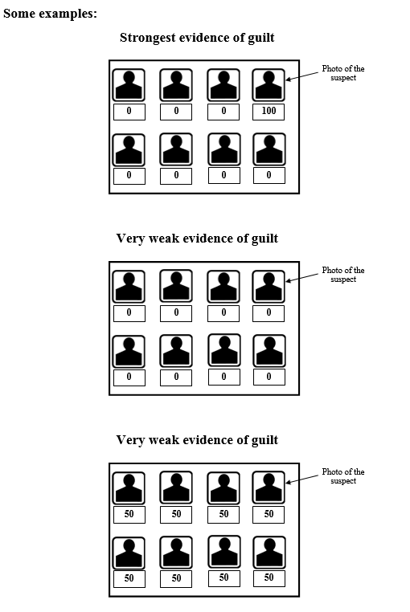

Information sheet for the No-discrimination control conditions – Experiment 3
Background information
- During an investigation of a crime, police officers might arrest a suspect (a person they think may have committed the crime).
- It is important for the police to work out whether they have arrested the right person. In other words, the police need to determine whether their suspect is the same person as the perpetrator (the person who actually committed the crime).
- To help determine whether the suspect is the perpetrator, police might ask a witness (a person who saw the crime take place) to view a lineup.
- A lineup contains the suspect and some “fillers”. Fillers are people who are known-to-be innocent (e.g., plain-clothed police or community volunteers) who match the general description of the perpetrator.
- The witness’s response to the lineup can help police to work out if their suspect is actually the perpetrator. There are different procedures for asking the witness to make their response.
The lineup procedure used in this investigation
- In the police investigation of this case, the witness viewed a lineup of 8 photos.
  - One photo was of the suspect in this case.
  - The other 7 photos were of fillers.
- The witness was asked whether any of the photos showed the perpetrator they had seen in relation to the crime in question.
- If the witness chose the photo of the suspect from the lineup, they were asked to give a rating (out of 100) to indicate how well the photo matched their memory of the perpetrator.
- The witness was instructed that:
  - If the photo is a perfect match to their memory, it should get a rating of 100.
  - If the photo does not match at all their memory, it should get a rating of 0.

