Supplemental Materials
Supplemental Methods
Measures
Body Mass Index. A standard stadiometer (Perspective Enterprises, Portage, Mich, USA) measured height to the nearest 1/8 inch. A digital scale (Wheelchair 6002, Scale-Tronix, Carol Stream, IL, USA) measured weight to the nearest 0.1 kg. Nursing staff performed all measurements.
Abdominal fat and body fat percentage. Dual energy X-ray absorptiometry (DEXA) scans were performed to assess abdominal and total body fat. The DEXA densitometry (GE Healthcare Lunar Prodigy, Madison, WI, USA) was adjusted to the fan beam mode. EnCore software version 9.15 was used. The coefficient of variation of the University of California, San Francisco Clinical & Translational Science Institute’s Clinical Research Center densitometer is 4% for fat mass. A measure of abdominal fat was derived from fat tissue from a rectangular region in the abdominal area. The top and bottom borders were defined by the upper boundary of the second lumbar vertebra and the lower edge of the fourth lumbar vertebra, respectively. The vertical sides were defined as the continuation of the lateral sides of the rib cage. This region correlates with magnetic resonance imaging of visceral fat among obese women (r = .74; Kamel, McNeill, & Wijk, 2000).
Stigmatizing Situations Inventory. The frequency with which participants encountered weight stigma was measured using the Stigmatizing Situations Inventory, created and validated by Myers and Rosen (1999). It is a self-report checklist inventory that assesses 50 possible weight-stigmatizing situations and asks about the frequency of each. A sample item is, “A doctor blaming unrelated physical problems to your weight.” Response options range from 0 = “never” to 9 = “daily.” A sum score was calculated such that higher numbers reflected greater frequency. Prior studies using the Stigmatizing Situations Scale have found associations with constructs such as psychological distress, negative body image, lower self-esteem (Myers & Rosen, 1999), and depression (Fettich & Chen, 2012; Wott & Carels, 2010), as well as behaviors such as binge eating (Wott & Carels, 2010) and avoidance of exercise (Vartanian & Novak, 2012).
Stigma Consciousness Scale. In addition to assessing the frequency of experiences of weight stigma, we also measured weight stigma consciousness using the Stigma Consciousness Scale (Pinel, 1999). The original measure assesses consciousness of stigma due to race/gender/sexual orientation. Respondents indicate their agreement with eight statements on a seven point scale ranging from 1 = “Strongly disagree” to 7 = “Strongly agree.” We adapted the scale to measure weight stigma by changing the critical keyword in the question stem to be weight-relevant. As an example, we adapted the item, “I never worry that my behaviors will be viewed as stereotypical of women,” to “I never worry that my behaviors will be viewed as stereotypical of the overweight.” Adapting the Stigma Consciousness Scale to other domains is a common approach (indeed, in her original validation study, Pinel [1999] used this same strategy to create separate scales for race, gender, and sexual orientation). Adapted scales for other social domains have been used in other peer-reviewed, published work (e.g., Bunn, Solomon, Miller, & Forehand, 2007). The Cronbach’s alpha for our adapted measure was in fact higher (.80) than the original Stigma Consciousness Scale for other domains (.77; Pinel, 1999). To capture the total experience of weight stigma, we summed z-scores derived from the total score of each scale to create a composite weight stigma measure, aggregating both reported actual experiences of exposure to stigmatizing situations and expectations that individuals will be stereotyped or discriminated against because of their weight, regardless of whether an overt stigmatizing situation occurred. The Cronbach’s alpha for the composite measure was .95.
Salivary Cortisol. Saliva samples were collected in 2 mL SaliCaps (IBL, Hamburg, Germany) via passive drool, using standard diurnal cortisol sampling collection protocols. The cortisol awakening response (CAR) was available for four days, but daily cortisol and slope were available for three days because one afternoon was part of a separate study.
Socioeconomic Status. Self-reported total household income before taxes (including all wages, salaries, and monetary income received by all individuals in the household) and educational attainment were measured in participants as an indicator of socioeconomic status, a potential confound. Both were reported on a 1-7 scale. Income categories were represented as 1 = Under $25,000, 2 = $25,000-$34,999, 3 = $35,000-$49,999, 4 = $50,000-$74,999, 5 = $75,000-$99,999, 6 = $100,000-$149,999, and 7 = Above $150,000. Educational attainment categories were represented as highest level of education completed, with 1 = Less than 12 years, 2 = High school graduate, 3 = Some college or technical school, 4 = AA degree, 5 = Bachelor’s degree, and 6 = Advanced degree.
Global Perceived Stress. Global psychological stress was measured using the Perceived Stress Scale (Cohen, Kamarck, & Mermelstein, 1983), a commonly used measure of general perceived stress, a potential confound. A sample item is, “How often have you felt nervous and stressed?” Respondents are asked to rate how often they experienced stress in the past month from 0 = “never” to 4 = “very often.” Cronbach’s alpha reliability was .84.

Sample Assays
Commercial chemiluminescence immunoassays measured salivary free cortisol levels (IBL Hamburg, Germany). Inter- and intra-assay coefficients of variation were below 9%. Commercial radioimmunoassay kits (Coat-A-Count Cortisol kit, Siemens Medical Solutions Diagnostics, Los Angeles, CA, USA) measured serum cortisol. The inter- and intra-assay coefficients of variation were below 6%. Oxidative stress samples for F2-isoprostanes were assayed according to protocols described in Milne et al. (2007). Inter- and intra-assay coefficients of variation were below 10%.

Supplemental Results
Q-Q plots indicated cortisol and F2-isoprostane values were non-normal and were natural-log-transformed. Outliers greater than 3 SD from the mean were winsorized to 3 SD from the mean. Physiologically implausible values (>100 nmol/L of cortisol) were excluded from analysis. Zero order correlations between all variables appear in Table S1. As oxidative stress is considered a marker of aging, it is customary to control for chronological age when modeling this outcome measure (Jacob, Hooten, Trzeciak, & Evans, 2013). To account for variables that might be considered confounds such as income, educational attainment, and global perceived stress, we first examined whether the potential confounding variable was related to either the exposure (weight stigma frequency, stigma consciousness, or composite measure) or the outcome (cortisol parameters and oxidative stress). In the event of a significant correlation (p < .05), we adjusted for these variables in the main regression analyses, but also present unadjusted analyses in Table S2.
Of these potential confounding variables, income was significantly related to weight stigma frequency (r = -.41, p < .01), such that those with lower income reported experiencing more weight stigmatizing situations. All analyses using the stigma frequency and composite variables in the main text therefore additionally control for income, although the pattern of results is similar when not controlling for income (see Table S2). Global perceived stress was positively related to weight stigma consciousness (r = .39, p < .01). All analyses using the stigma consciousness and composite variables in the main text therefore additionally control for global perceived stress, although the pattern of results is similar when not controlling for this variable (see Table S2).
In the case of perceived stress, however, weight stigma, as a source of social-evaluative threat, might contribute to global perceptions of stress (e.g., by perceiving greater threats in the environment, having less ability to control situations, or having fewer resources to cope). Thus, in this case, perceived stress scores could be functioning as a mediator, rather than as a confound, consistent with the model put forth by Dickerson and Kemeny (2004). In other words, perceived stress may be on the pathway between weight stigma and the outcome measures, such that weight stigma contributes to greater perceptions of perceived stress, which in turn increases cortisol levels. Indeed, when we control for global perceived stress, the relationships between weight stigma consciousness and AUC and the CAR are attenuated. Moreover, perceived stress was significantly related to the CAR, and these findings are consistent with both a mediation model and prior literature, given the strong relationships between perceived stress and the CAR in particular (Chida & Steptoe, 2009). Because of our relatively small sample and the fact that adiposity is a critically important covariate, we used the INDIRECT macro available from Preacher and Hayes (2008), which uses bootstrap estimation for more reliable estimates given smaller samples and, unlike other methods, can incorporate covariates. We found that perceived stress was a significant mediator of the relationship between weight stigma consciousness and the CAR (estimate = 0.13, SE = 0.08, bias-corrected 95% confidence interval: 0.03, 0.45), controlling for abdominal fat.
An alternative way of modeling the weight stigma variables would be to include both weight stigma measures in a regression model to essentially isolate the effects of stigma consciousness independent of actual experiences with stigma, and vice versa. When doing so, however, all previously observed effects become non-significant (all p > .14). This is likely due to the high degree of overlap in the two constructs (r = .56, p < .001).
Furthermore, given past theory on stigma consciousness versus the actual experience of events (Kaiser, Vick, & Major, 2006), a theoretically-consistent alternative model would be to test whether the association of weight stigma frequency on the outcome measures might depend on weight stigma consciousness. In other words, we tested the hypothesis that the more stigma conscious an individual is, the more likely they are to notice and be affected by stigmatizing events; an interaction hypothesis. We therefore tested frequency x consciousness interactions using the MODPROBE macro available from Hayes and Matthes (2009), including all appropriate covariates for each respective model. All interaction terms were non-significant after adjustment for respective covariates (daily total AUC: b = 0.0002, SE = 0.0003, p = .47; morning serum: b = -0.0002, SE = 0.0003, p = .47; awakening response: b = 0.002, SE = 0.005, p = .75; diurnal slope: b = -0.003, SE = 0.004, p = .43; F2-isoprostanes: b = 0.0002, SE = 0.002, p = .40).
Sensitivity analyses. Although we used abdominal fat as a measure of adiposity, we also conducted analyses controlling for total body fat percentage as an alternative measure of overall adiposity. The analyses when controlling for total body fat percentage rather than abdominal fat yielded a similar pattern of findings (see Table S3).
Finally, the pattern of associations in the main analyses controlled for abdominal fat and other potential outcomes was similar between women in the lowest BMI quartile (BMI: 24.89-27.61) and those higher in BMI (Figure S1). This suggests that weight stigma may be related to health outcomes not only for obese individuals but even those who are nearer to what is considered "normal" weight.

Supplemental References
Bunn, J. Y., Solomon, S. E., Miller, C., & Forehand, R. (2007). Measurement of stigma in people with HIV: A reexamination of the HIV Stigma Scale. AIDS Education & Prevention, 19(3), 198-208.
Chida, Y., & Steptoe, A. (2009). Cortisol awakening response and psychosocial factors: a systematic review and meta-analysis. Biological Psychology, 80(3), 265-278.
Cohen, S., Kamarck, T., & Mermelstein, R. (1983). A global measure of perceived stress. Journal of Health and Social Behavior, 4, 385-396.
Dickerson, S. S., & Kemeny, M. E. (2004). Acute stressors and cortisol responses: a theoretical integration and synthesis of laboratory research. Psychological Bulletin, 130(3), 355.
Fettich, K. C. and Chen, E. Y. (2012), Coping with obesity stigma affects depressed mood in African-American and White candidates for bariatric surgery. Obesity, 20, 1118–1121.
Hayes, A. F., & Matthes, J. (2009). Computational procedures for probing interactions in OLS and logistic regression: SPSS and SAS implementations. Behavior Research Methods 41, 924-936.
Jacob, K. D., Hooten, N. N., Trzeciak, A. R., & Evans, M. K. (2013). Markers of oxidant stress that are clinically relevant in aging and age-related disease. Mechanisms of Ageing and Development, 134, 139-157.
Kaiser, C. R., Vick, S. B., & Major, B. (2006). Prejudice expectations moderate preconscious attention to cues that are threatening to social identity. Psychological Science, 17(4), 332-338.
Kamel, E. G., McNeill, G., & Wijk, M. C. (2000). Usefulness of anthropometry and DXA in predicting intra‐abdominal fat in obese men and women. Obesity Research, 8(1), 36-42.
Milne, G. L., Yin, H., Brooks, J. D., Sanchez, S., Jackson Roberts, L., 2nd, & Morrow, J. D. (2007). Quantification of F2-isoprostanes in biological fluids and tissues as a measure of oxidant stress. Methods in Enzymology, 433, 113-126.
Myers, A., & Rosen, J. C. (1999). Obesity stigmatization and coping: relation to mental health symptoms, body image, and self-esteem. International Journal of Obesity and Related Metabolic Disorders, 23(3), 221-230.
Pinel, E. C. (1999). Stigma consciousness: the psychological legacy of social stereotypes. Journal of Personality and Social Psychology, 76(1), 114.
Vartanian, L. R. and Novak, S. A. (2011). Internalized societal attitudes moderate the impact of weight stigma on avoidance of exercise. Obesity, 19, 757–762.
Wott, C. B., & Carels, R. A. (2010). Overt weight stigma, psychological distress and weight loss treatment outcomes. Journal of Health Psychology, 15(4), 608-614.

Table S1. Zero-order correlations among study variables.

 | 2 | 3 | 4 | 5 | 6 | 7 | 8 | 9 | 10 | 11 | 12 | 13 | 14
1. Composite Weight Stigma | .88*** | .88*** | .33* | .39** | .39** | .03 | -.24 | .28 | .26 | .36* | .33* | .01 | .47**
2. Weight Stigma Frequency |  | .56** | .45** | .52** | .44** | .16 | -.41** | .11 | .21 | .25 | 0.2 | .05 | .42**
3. Weight Stigma Consciousness |  |  | -.10 | .17 | .23 | -.10 | -.04 | .39** | .25 | .36* | .35* | -.01 | .39**
4. Abdominal Fat |  |  |  | .77*** | .67*** | .03 | -.27 | -.07 | -.20 | -.03 | -.02 | -.17 | .36*
5. BMI |  |  |  |  | .69*** | .10 | -.32* | -.11 | -.06 | .11 | .10 | -.16 | .38**
6. Total Body Fat % |  |  |  |  |  | .24 | -.13 | .05 | -.16 | -.09 | .06 | -.16 | .31*
7. Education |  |  |  |  |  |  | -.19 | .10 | -.06 | -.06 | -.10 | .07 | .06
8. Income |  |  |  |  |  |  |  | .22 | -.03 | -.12 | .14 | -.14 | -.15
9. Global Perceived Stress |  |  |  |  |  |  |  |  | .03 | .28 | .44** | -.24 | .16
10. Morning Serum Cortisol |  |  |  |  |  |  |  |  |  | .05 | .33* | -.15 | .14
11. Daily Total Cortisol (AUC) |  |  |  |  |  |  |  |  |  |  | .52** | .36* | -.03
12. CAR |  |  |  |  |  |  |  |  |  |  |  | -.28 | .18
13. Cortisol Diurnal Slope |  |  |  |  |  |  |  |  |  |  |  |  | -.03
14. F2-Isoprostanes
Note: Abdominal fat units are grams; Cortisol units are ln(mg/dL) for serum and ln(nmol/L) for saliva; F2-Isoprostane units are ln(ng/mL); BMI = Body Mass Index; AUC = Area Under the Curve; CAR = Cortisol Awakening Response; *p < 0.05 (2-tailed), **p < 0.01 (2-tailed), ***p < 0.001 (2-tailed).

Table S2. Multiple regression results of weight stigma and outcome measures unadjusted for income or global perceived stress.
 | Predictor | ß | b | SE |  | 95% CI
Composite Weight Stigma Frequency + Consciousness
Cortisol
Morning Serum | Composite | 0.37* | 0.33* | 0.13 |  | 0.06 , 0.60
(n = 44) | Abdominal Fat | -0.31* | 0.00* | 0.00 |  | -4E⁻⁴ , -7E⁻⁶
Daily Total (AUC) | Composite | 0.42* | 0.37* | 0.15 |  | 0.07 , 0.66
(n = 37) | Abdominal Fat | -0.18 | 0.00 | 0.00 |  | 0.00 , 0.00
Awakening Response | Composite | 0.38* | 6.66* | 2.79 |  | 1.03 , 12.30
(n = 41) | Abdominal Fat | -0.15 | -0.002 | 0.002 |  | -0.01 , 0.002
Diurnal Slope | Composite | 0.07 | 0.90 | 2.10 |  | -3.35 , 5.15
(n = 40) | Abdominal Fat | -0.20 | -0.002 | 0.001 |  | -0.004 , 0.001
F2-Isoprostanes | Composite | 0.36* | 0.29* | 0.11 |  | 0.06 , 0.51
(n = 44) | Abdominal Fat | 0.21 | 0.00 | 0.00 |  | 0.00, 0.00
 | Age | -0.20 | -0.01 | 0.01 |  | -0.02 , 0.004
Weight Stigma Frequency
Cortisol
Morning Serum | Frequency | 0.36* | 0.004* | 0.002 |  | 0.001 , 0.01
(n = 44) | Abdominal Fat | -0.38* | -2E⁻⁴* | 1E⁻⁴ |  | -4E⁻⁴ , -3E⁻⁵
Daily Total (AUC) | Frequency | 0.34 | 0.004 | 0.002 |  | 0.00 , 0.01
(n = 37) | Abdominal Fat | -0.20 | 0.00 | 0.00 |  | 0.00 , 0.00
Awakening Response | Frequency | 0.28 | 0.06 | 0.04 |  | -0.02 , 0.14
(n = 41) | Abdominal Fat | -0.17 | -0.002 | 0.002 |  | -0.01 , 0.002
Diurnal Slope | Frequency | 0.15 | 0.03 | 0.03 |  | -0.04 , 0.08
(n = 40) | Abdominal Fat | -0.24 | -0.002 | 0.001 |  | -0.01 , 0.001
F2-Isoprostanes | Frequency | 0.29 | 0.003 | 0.002 |  | 0.00 , 0.01
(n = 44) | Abdominal Fat | 0.24 | 0.00 | 0.00 |  | 0.00 , 0.00
 | Age | -0.10 | -0.004 | 0.01 |  | -0.02, 0.01
Weight Stigma Consciousness
Cortisol
Morning Serum | Consciousness | 0.28 | 0.02 | 0.01 |  | -0.001 , 0.03
(n = 45) | Abdominal Fat | -0.23 | 0.00 | 0.00 |  | 0.00 , 0.00
Daily Total (AUC) | Consciousness | 0.38* | 0.02* | 0.01 |  | 0.003 , 0.04
(n = 38) | Abdominal Fat | -0.09 | 0.00 | 0.00 |  | 0.00 , 0.00
Awakening Response | Consciousness | 0.36* | 0.38* | 0.16 |  | 0.06 , 0.70
(n = 42) | Abdominal Fat | -0.06 | -0.001 | 0.002 |  | -0.004 , 0.003
Diurnal Slope | Consciousness | 0.01 | 0.01 | 0.12 |  | -0.24 , 0.25
(n = 41) | Abdominal Fat | -0.18 | -0.001 | 0.001 |  | -0.004 , 0.001
F2-Isoprostanes | Consciousness | 0.35* | 0.02* | 0.01 |  | 0.004 , 0.03
(n = 38) | Abdominal Fat | 0.27 | 0.00 | 0.00 |  | 0.00 , 0.00
 | Age | -0.25 | -0.01 | 0.01 |  | -0.03 , 0.001
Note: Cortisol units are ln(mg/dL) for serum and ln(nmol/L) for saliva; F2-Isoprostane units are ln(ng/mL); CI = Confidence Interval; *p < 0.05 (2-tailed); ß values represent standardized units, whereas b values represent raw values. We provide >3 decimal places only when p < .05.

Table S3. Multiple regression results of weight stigma and outcome measures controlling for total body fat percentage and other confounds.
 | Predictor | ß | b | SE |  | 95% CI
Composite Weight Stigma Frequency + Consciousness
Cortisol
Morning Serum | Composite | 0.41* | 0.37* | 0.15 |  | 0.06 , 0.68
(n = 44) | % Body Fat  Income | -0.31  -0.01 | -2.52  -0.001 | 1.27  0.04 |  | -5.09 , 0.04  -0.08 , 0.08
 | Global Stress | -0.09 | -0.06 | 0.11 |  | -0.27 , 0.15
Daily Total (AUC) | Composite | 0.34 | 0.30 | 0.15 |  | -0.002 , 0.60
(n = 37) | % Body Fat  Income | -0.19  -0.13 | -1.35  -0.30 | 1.13  0.04 |  | -3.65 , 0.96  -0.11 , 0.05
 | Global Stress | 0.23 | 0.13 | 0.09 |  | -0.06 , 0.33
Awakening Response | Composite | 0.31 | 5.43 | 2.88 |  | -0.42 , 11.27
(n = 41) | % Body Fat  Income | -0.06  0.16 | -8.68  0.78 | 23.74  0.74 |  | -56.77 , 39.41  -0.71 , 2.28
 | Global Stress | 0.34* | 4.55* | 2.01 |  | 0.47 , 8.63
Diurnal Slope | Composite | 0.15 | 1.87 | 2.30 |  | -2.80 , 6.54
(n = 40) | % Body Fat  Income | -0.21  -0.03 | -22.40  -0.11 | 18.76  0.60 |  | -60.45 , 15.65  -1.33 , 1.11
 | Global Stress | -0.24 | -2.25 | 1.57 |  | -5.44 , 0.94
F2-Isoprostanes | Composite | 0.35* | 0.28* | 0.13 |  | 0.02 , 0.54
(n = 44) | % Body Fat Age  Income | 0.10  -0.20  -0.07 | 0.72  -0.01  -0.02 | 1.11  0.01  0.03 |  | -1.53 , 2.97  -0.03 , 0.01  -0.08, 0.06
 | Global Stress | 0.07 | 0.04 | 0.09 |  | -0.14 , 0.22
Weight Stigma Frequency
Cortisol
Morning Serum | Frequency | 0.34* | 0.004* | 0.002 |  | 0.00 , 0.01
(n = 44) | % Body Fat  Income | -0.35*  0.008 | -2.91*  0.002 | 1.35  0.04 |  | -5.64 , -0.18  -0.08 , 0.08
Daily Total (AUC) | Frequency | 0.32 | 0.004 | 0.002 |  | -0.001 , 0.01
(n = 37) | % Body Fat  Income | -0.24  -0.05 | -1.75  -0.01 | 1.27  0.04 |  | -4.33 , 0.83  -0.09 , 0.07
Awakening Response | Frequency | 0.39* | 0.08* | 0.04 |  | 0.002 , 0.17
(n = 41) | % Body Fat  Income | -0.17  0.27 | -25.84  1.22 | 25.92  0.78 |  | -78.35 , 26.68  -0.36 , 2.81
Diurnal Slope | Frequency | 0.11 | 0.02 | 0.03 |  | -0.05 , 0.09
(n = 40) | % Body Fat  Income | -0.20  -0.07 | -21.56  -0.24 | 20.42  0.62 |  | -62.97 , 19.84  -1.50 , 1.03
F2-Isoprostanes | Frequency | 0.34 | 0.003 | 0.002 |  | 0.00 , 0.01
(n = 44) | % Body Fat Age  Income | 0.04  -0.08  -0.11 | 0.27  -0.003  -0.02 | 1.08  0.01  0.03 |  | -1.92 , 2.45  -0.02 , 0.01  -0.09 , 0.05
Weight Stigma Consciousness
Cortisol
Morning Serum | Consciousness | 0.35* | 0.02* | 0.01 |  | 0.001 , 0.04
(n = 45) | % Body Fat  Global Stress | -0.23  -0.11 | -1.87  -0.07 | 1.21  0.11 |  | -4.31 , 0.14  -0.29 , 0.15
Daily Total (AUC) | Consciousness | 0.32 | 0.32 | 0.01 |  | -0.001 , 0.03
(n = 38) | % Body Fat  Global Stress | -0.14  0.18 | -0.14  0.18 | 1.10  0.10 |  | -3.23 , 1.24  -0.09 , 0.30
Awakening Response | Consciousness | 0.23 | 0.25 | 0.16 |  | -0.09 , 0.57
(n = 42) | % Body Fat  Global Stress | -0.01  0.36* | -1.17  4.86* | 22.57  2.02 |  | -48.86 , 44.53  0.78 , 8.95
Diurnal Slope | Consciousness | 0.12 | 0.09 | 0.13 |  | -0.17 , 0.35
(n = 41) | % Body Fat  Global Stress | -0.17  -0.26 | -18.26  -2.38 | 17.34  1.54 |  | -53.39 , 16.88  -5.50 , 0.75
F2-Isoprostanes | Consciousness | 0.34* | 0.02* | 0.01 |  | 0.001 , 0.03
(n = 45) | % Body Fat Age  Global Stress | 0.15  -0.26  0.03 | 1.08  -0.01  0.02 | 1.07  0.01  0.09 |  | -1.08 , 3.23  -0.03 , 0.01  -0.16 , 0.20
Note: Cortisol units are ln(mg/dL) for serum and ln(nmol/L) for all other variables; F2-Isoprostane units are ln(ng/mL); CI = Confidence Interval; *p < 0.05 (2-tailed); ß values represent standardized units, whereas b values represent raw values.

Figure S1. Associations between composite weight stigma and outcome measures comparing the lowest quartile (<27.7) of BMI to all others. The association is similar between the two groups, consistent with the interpretation that weight stigma may even affect women who are nearer to what is considered "normal" BMI. Panel A. Weight stigma and morning serum cortisol. Panel B. Weight stigma and total diurnal cortisol AUC. Panel C. Weight stigma and cortisol awakening response. Panel D. Weight stigma and F2-isoprostanes.

A.

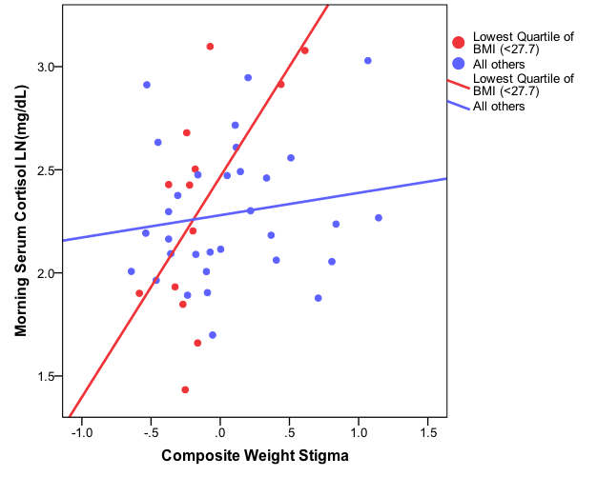

B.

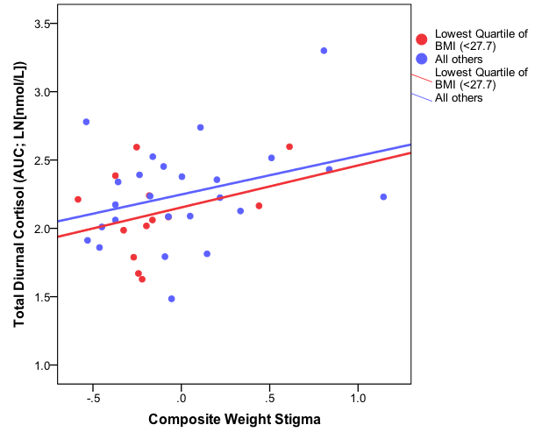

C.
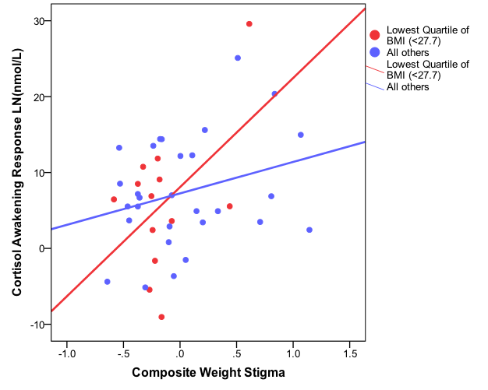

D.

