Supplementary information
Bijleveld, E., & Knufinke M. (under review). Exposure to bright light biases effort-based decisions in humans.

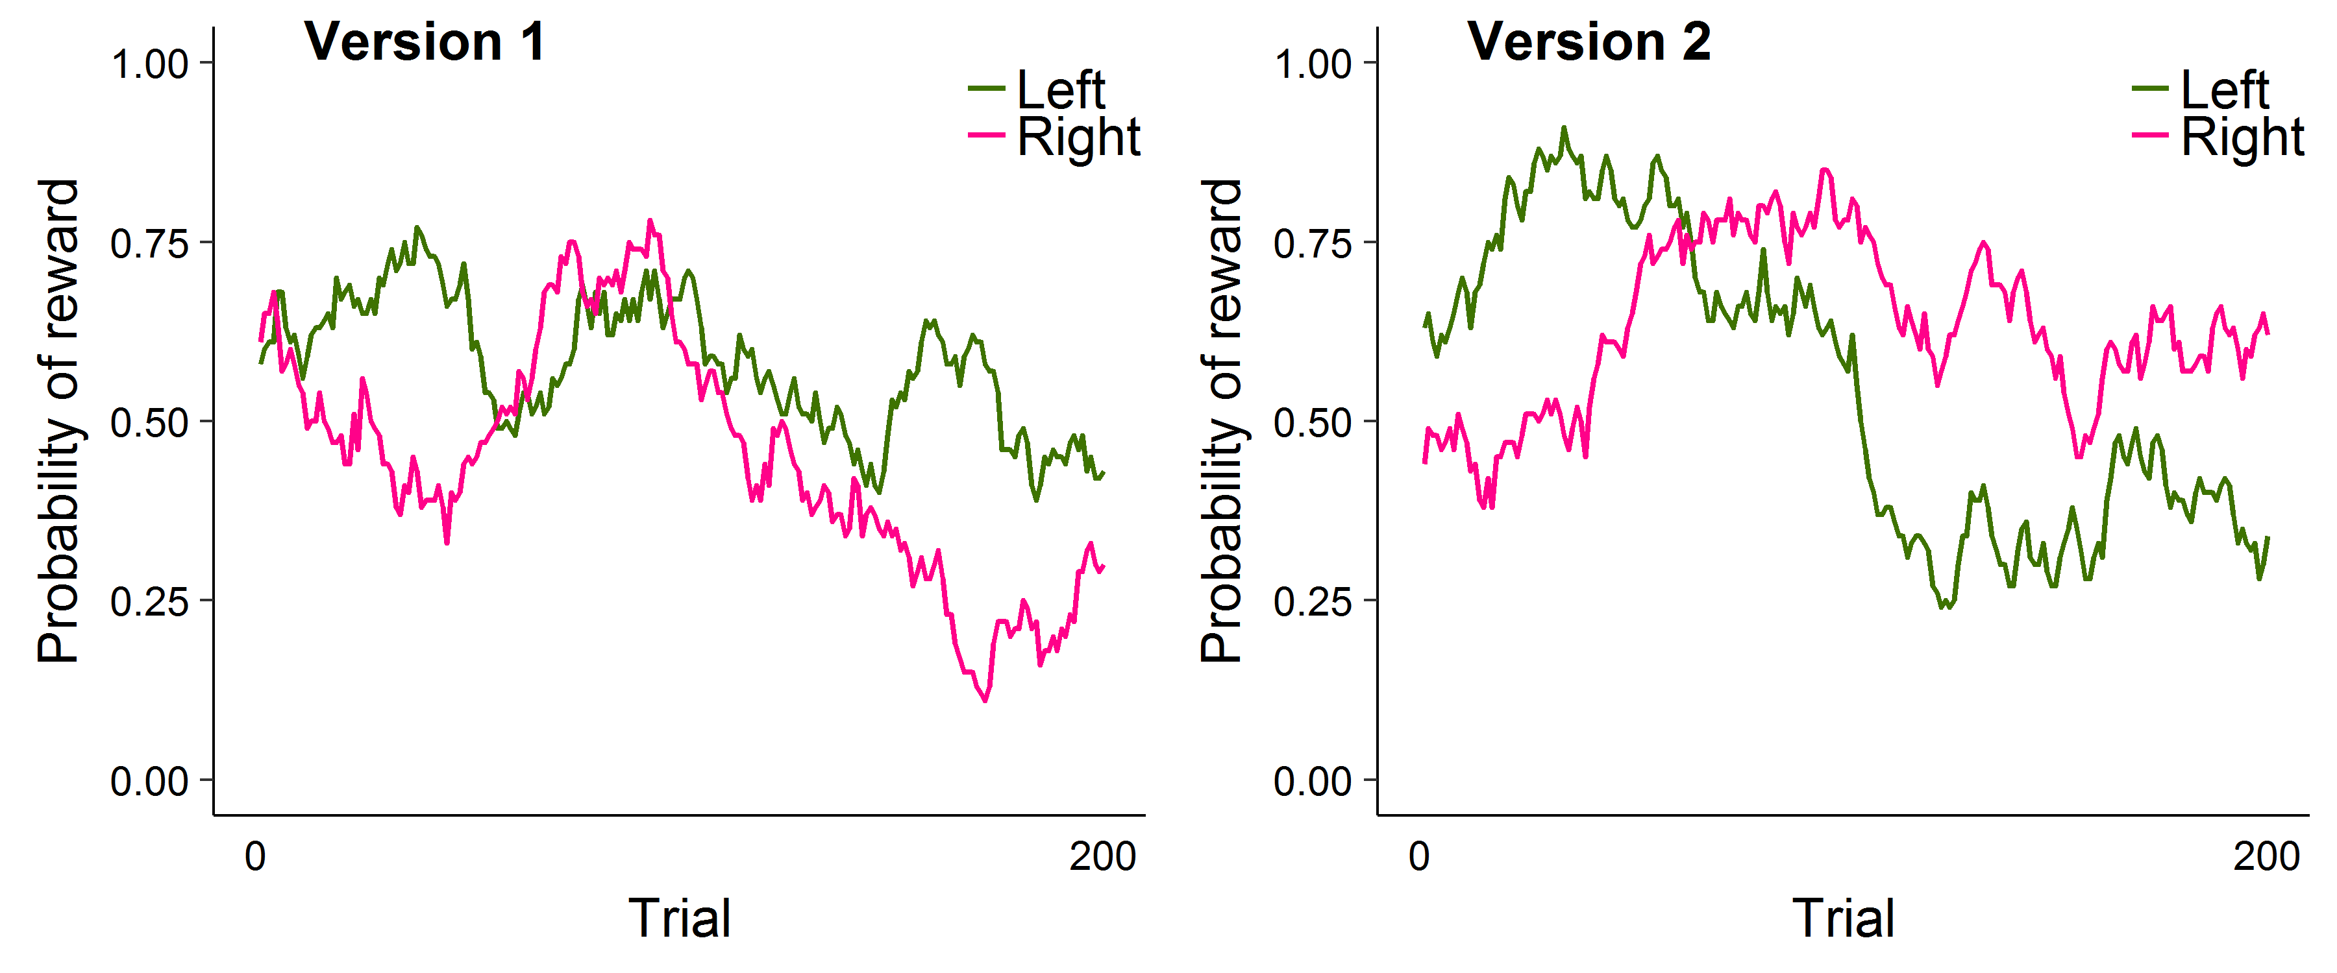

Supplementary Figure S2. Probability of receiving reward feedback throughout the two-armed bandit task (2ABT), separately for each choice option (left vs. right) and separately for each version of the task. In one of the sessions, participants got version 1; in the other session, version 2 (see Methods in main text).

 | 2 | 3 | 4 | 5 | 6 | 7 | 8 | M | SD
1. EEfRT hard choices all trials | .74** | .91** | .81** | .09 | .14 | .15 | .39* | 0.49 | 0.19
2. EEfRT hard choices low prob. |  | .54** | .34* | .22 | -.02 | -.13 | .07 | 0.19 | 0.23
3. EEfRT hard choices medium prob. |  |  | .68** | .15 | .16 | .21 | .47** | 0.54 | 0.26
4. EEfRT hard choices high prob. |  |  |  | -.12 | .13 | .29 | .37* | 0.74 | 0.22
5. 2ABT Learning rate α |  |  |  |  | -.30 | -.32 | -.01 | 0.57 | 0.32
6. 2ABT Inverse temperature τ |  |  |  |  |  | .33 | .16 | 2.51 | 1.46
7. 2ABT “win” feedback |  |  |  |  |  |  | .19 | 0.57 | 0.07
8. BART Adjusted score |  |  |  |  |  |  |  | 35.4 | 14.2

Supplementary Table S1. Correlations between the main indices of task behavior, for bright light sessions. The rightmost two columns contain the mean and the standard deviation for that row.

 | 2 | 3 | 4 | 5 | 6 | 7 | 8 | M | SD
1. EEfRT hard choices all trials | .77** | .94** | .87** | .09 | .10 | .08 | .16 | 0.51 | 0.26
2. EEfRT hard choices low prob. |  | .62** | .44** | -.09 | .21 | .13 | -.02 | 0.23 | 0.29
3. EEfRT hard choices medium prob. |  |  | .81** | .17 | -.02 | -.04 | .17 | 0.55 | 0.31
4. EEfRT hard choices high prob. |  |  |  | .17 | .03 | .12 | .21 | 0.75 | 0.28
5. 2ABT Learning rate α |  |  |  |  | -.58** | -.24 | -.03 | 0.59 | 0.31
6. 2ABT Inverse temperature τ |  |  |  |  |  | .29 | .02 | 2.51 | 1.66
7. 2ABT “win” feedback |  |  |  |  |  |  | -.29 | 0.57 | 0.06
8. BART Adjusted score |  |  |  |  |  |  |  | 36.4 | 16.9

Supplementary Table S2. Correlations between the main indices of task behavior, for dim light sessions. The rightmost two columns contain the mean and the standard deviation for that row.

 | Estimate | SE | df | t | p
1. Inverse temperature τ
Sex = female | -0.7 | 0.5 | 34.1 | -1.5 | 0.145
Session | 0.6 | 0.3 | 34.3 | 2.4 | 0.020
Walk | 0.3 | 0.3 | 33.0 | 1.0 | 0.335
Brightness = bright | 0.0 | 0.3 | 33.0 | 0.0 | 0.998
2. Proportion of “win” feedback
Sex = female | -3.8 | 2.4 | 33.9 | -1.6 | 0.116
Session | 17.5 | 2.1 | 35.8 | 8.5 | <.001
Walk | 0.8 | 2.1 | 32.8 | 0.4 | 0.693
Brightness = bright | -0.6 | 2.1 | 32.8 | -0.3 | 0.773

Supplementary Table S3. Results from two general linear mixed models, examining two aspects of task behavior during the two-armed bandit task (2ABT). We had no specific predictions for these analyses.

Term | Estimate | SE | Z | p
Sex = female | 0.4 | 0.8 | 0.5 | 0.637
Trial number | -1.2 | 0.6 | -2.0 | 0.040
Session number | 0.4 | 0.3 | 1.3 | 0.182
Reward probability | -1.1 | 0.9 | -1.2 | 0.244
Reward value | 1.1 | 0.2 | 4.6 | <0.001
Expected value | 3.6 | 0.5 | 7.8 | <0.001
Change in sadness | 0.3 | 0.4 | 0.7 | 0.502
Reward value x Change in sadness | -0.2 | 0.2 | -1.2 | 0.242

Supplementary Table S4. Results from a generalized linear mixed model, which we used to examine choices (to do the difficult task) during the Effort Expenditure for Rewards Task (EEfRT). We ran this model to explore whether bright light (vs. dim light) may have exerted its influence on choice via changes in sadness.

Supplementary Text: Session order effects.
As we found that session number (1 vs. 2) predicted task behavior in the EEfRT and the BART, we explored whether the effects of brightness were moderated by session number. In other words, we examined the possibility that the effect of brightness was different during the first vs. the second session.
For the EEfRT, we re-ran the model than included all main effects (i.e., Model 1; see Table 2). This time, however, we added the brightness × session interaction to the model. This interaction was not significant, Est = 0.08, z = 0.1, p = .953, suggesting that the (null) effect of brightness on people’s tendency to choose the difficult task, was not substantially dependent on session order. Next, we attempted to re-run the model in which we found the reward value × brightness interaction (i.e., Model 3; see Table 2), while adding the reward value × brightness × session three-way interaction. We ran into convergence problems when trying to run this model; we thus proceeded by simplifying the random-effects structure, as suggested by Barr et al. (2013; R syntax is provided at https://osf.io/nqdhf/). The reward value × brightness × session three-way interaction was not significant, Est = -0.37, z = -0.5, p = .609, suggesting that the effect of brightness on people’s sensitivity of reward was not substantially dependent on session order. We note, though, that the latter result should be interpreted with some caution due to the convergence issues that we encountered.
For the 2ABT, we re-ran the model that was described in the main text. This time, however, we added the brightness × session interaction. This interaction was not significant, Est = 0.32, t(33.0) = 1.8, p = .083, suggesting that the (null) effect of brightness on learning rate α was not substantially dependent on session order.
For the BART, we re-ran the model that was described in the main text. Also here, we added brightness × session interaction. This interaction was not significant, Est = -10.6, t(33.0) = -1.0, p = .316, suggesting that the (null) effect of brightness on BART score was not substantially dependent on session order

