Supplementary Materials for “Forward Flow”

Information about LSA Engine
The LSA engine was implemented in Python and calculates the semantic distance between words. Each word is represented by an n-dimensional vector. The distance metric the engine uses is the cosine similarity between the two vectors. This computation was implemented using the SciPy Python package (Jones, Oliphant, & Peterson, 2014).

The set of all vector representations of the words in a corpus is often referred to as an LSA model (e.g., (Ștefănescu, Banjade, & Rus, 2014)). The studies in this paper used LSA models that were built from the same Touchstone Applied Sciences Associates (TASA) corpus used by Landauer and colleagues on their LSA server (http://lsa.colorado.edu/). These LSA models were built and validated by the SEMILAR Project (Ștefănescu et al., 2014).

Our entire software package, including the LSA engine, includes modules for the latent semantic analysis of users’ own corpora and custom LSA model generation, queries to LSA models, SQL database functionality, an online data collection interface, and a webserver with web interfaces for the LSA query functionalities and for data collection. The source code repository is at: https://github.com/chene5/dynamics. The software that we have written is open-source and users are invited to modify the source code to suit their own research needs.

The LSA analysis and model generation module includes an interactive command line interface to the Gensim natural language processing package (Rehurek & Sojka, 2010) This interface allows researchers to conduct LSA on their own corpora and build custom LSA models. This provides users the ability to analyze semantic similarity between words based on different LSA models.

The LSA model query module allows users to conduct their own analyses of the semantic similarity of words and texts. The semantic similarity of words can be analyzed based on any TASA corpus model from the SEMILAR Project and any LSA model built by Gensim. These queries can analyze large numbers of words and texts and generate a variety of analytical outputs, including matrices of pairwise comparisons and serial forward flow results.

The SQL database module allows users to store and retrieve data in a SQL database. The module uses the SQLAlchemy package (https://www.sqlalchemy.org/) and thus can run on a number of different implementations and deployments of SQL, including on cloud database services such as Amazon Web Services’ Relational Database Service.

The online data collection module allows users to collect data for studies that use different tasks and survey measures, beyond the forward flow measures. This provides users the ability to embed forward flow into their own studies. The web interface uses the Bootstrap CSS/HTML/JavaScript framework (http://getbootstrap.com/).

The web server module allows users to deploy their own web-based LSA servers. This provides users with a number of easy-to-use interfaces to query their LSA models and retrieve user data. There are web-based interfaces both for directly entering texts as well as for uploading larger sets of texts in CSV data files. This module uses the Flask framework (http://flask.pocoo.org/) and is ready for deployment on users’ own computers or, with the proper configuration, on cloud computing services such as Amazon Web Services’ Elastic Beanstalk service.
Instructions for All Tasks

Free Association: “On this page, starting with the word ‘[seed word]’, your job is to write down the next word that follows in your mind from the previous word. Please put down only single words, and do not use proper nouns (such as names, brands, etc.).” NB: Participants wrote 19 words, for a total word list of 20 words.
Seed words: Study 1: Candle, Snow; Study 2: Toaster; Study 3: Paper, Toaster, Table, Snow, Candle, Bear; Study 4: Table; Study 5: Paper, Snow, Table, Candle, Bear, Toaster; Study 6: Paper, Snow, Table, Candle, Bear, Toaster
Novel Uses: “Imagine that someone gives you a box of popsicle sticks. In the spaces below, please indicate three possible uses for the popsicle sticks. Be as creative as possible.”
Charity Idea: “Imagine you work for a charity organization whose goal is to prevent and cure cancer. The organization is located in a suburb near a major city. Your organization's current goal is to think of ways to increase charitable donations from members of the surrounding community.
Your task is to generate three creative solutions to the problem of how to increase charitable donations from members of the surrounding community.”
Caption: “Please write a few creative sentences or a paragraph for the following images. There are no set rules or expectations; just write whatever you feel most creatively describes or fits with each image.”
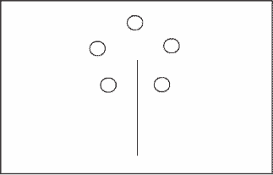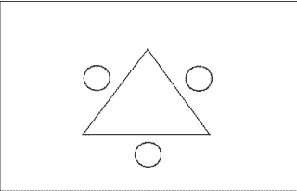

Similarity: “For each of the following pairs, please describe the most creative way that the two are similar to each other.

Cat & Mouse

Train & Tractor

Desk & Table”

Draw an Alien: “Please draw an extraterrestrial in the space below. Be creative.”

Remote Associates Task: “Below, you will see multiple lists of three words. For each, please think of a 4th word that can be paired with each of the other words to create a new term. (Example: Cottage/Swiss/Cake = “cheese,” because it forms Cottage Cheese/ Swiss Cheese/ Cheesecake)
Complete as many as you can in one minute.
Cottage/Swiss/cake
Fish/mine/rush
River/note/account
Mouse/bear/sand
Glass/rush/happy
Puppy/true/letter
Sense/courtesy/place
Shine/beam/struck
Age/mile/sand
Hill/tank/secret
Eight/stick/skate”

GRE Verbal: “Choose the answer which contains a pair of words with a relationship most similar to the relationship between the pair of words in capital letters.
PONDER : PROBLEM
- Remove : doubt
- Capture : runaway
- Seize : time
- Ruminate : idea
- Curl : hair

Although it does contain some pioneering ideas, one would hardly characterize the work as _____

- Orthodox
- Eccentric
- Trifling
- Conventional
- Innovative
It was her view the country’s problems had been _____ by foreign technocrats, so that to ask for such assistance again would be counterproductive.
- Ameliorated
- Ascertained
- Exacerbated
- Overlooked

Cognitive Reflection Task: “Please answer the following questions to the best of your ability:
A bat and a ball cost $1.10 in total. The bat costs $1.00 more than the ball. How much does the ball cost?
If it takes 5 machines 5 minutes to make 5 widgets, how long would it take 100 machines to make 100 widgets
In a lake, there is a patch of lily pads. Every day, the patch doubles in size. If it takes 48 days for the patch to cover the entire lake, how long would it take for the patch to cover half of the lake?”

Raven’s Matrices
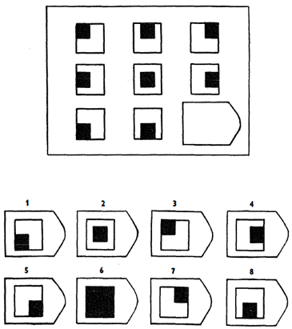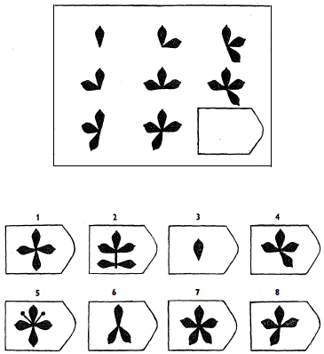

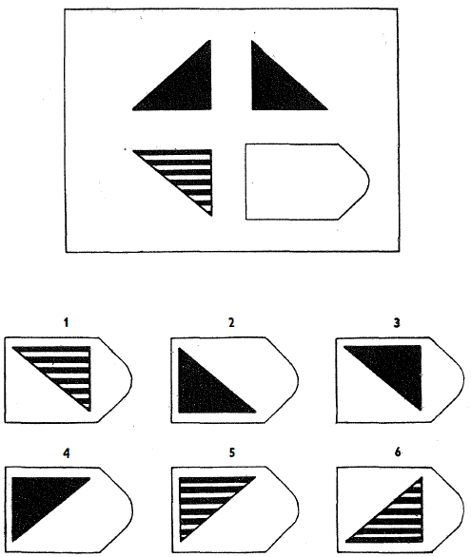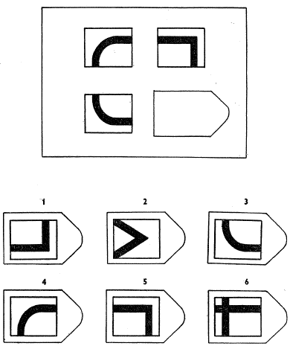

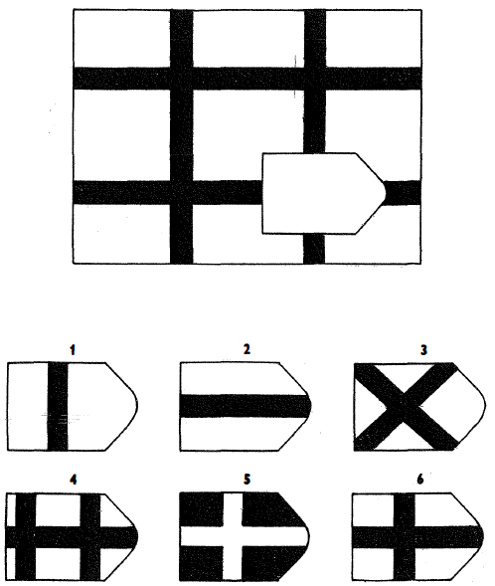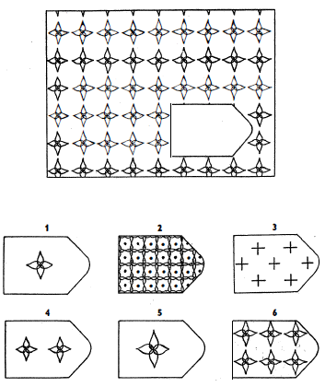
Additional Methods and Analyses
Pilot Study:
As an initial investigation, this examined a small sample of amateur actors (N = 33, 54.3% female, M_{age} = 41.03, SD_{age} = 17.24) who attended a free acting workshop. Participants first completed a free association measure with no instructions other than to sequentially list 20 single-word thoughts that were not proper nouns. Participants then completed the novel uses task, an alien drawing task, and a “charity fundraiser” task. Unlike the free association measure, participants were explicitly instructed to be creative on these tasks.
Forward flow was calculated with our LSA engine.
As hypothesized, forward flow predicted creativity ratings, r(31) = .51, p = .003, providing initial evidence for an association between baseline forward motion of naturalistic thought and creativity.
Novel Uses Task was correlated with Charity Idea, r(31)=.4, p=.018. The Charity Idea was marginally significantly correlated with the Draw an Alien task, r(31) = .328, p= .055, but the correlation between Novel Uses and Draw an Alien was not significant, r(31) = .242, p = .161, likely due to low power.
Study 1:
Creativity ratings were reliable across the three coders for both novel uses (α = .89) and the draw an alien (α = .91), and these tasks were significantly correlated r(215) = .39, p < .001. The CRT and GRE responses were also significantly correlated r(215) = .21, p = .002.
Study 2:
Creativity ratings were reliable across the three coders for novel uses (α = .90), the charity idea (α = .93), the caption (α = .94), and similarity measure (α = .92), and these tasks were significantly correlated rs(517) > .27, ps < .001. The Ravens matrices measures and GRE responses were also significantly correlated r(517) = .26, p < .001.
Study 3: Drama Students
Participants from the creative sample were enrolled in one of the following courses: Lighting Design I, Theatre for Social Change, Acting for Non-Majors, Beginning Acting for the Major, Intermediate Acting for the Major, and Playwriting II (59.0% female, M_{AGE} = 19.97) Students in the lecture sample were enrolled in Perspectives in Drama, a lecture-based course on the history and art of theater (56.2%% female, M_{AGE} = 18.91).
Creativity ratings were reliable across the three coders for both novel uses (α = .89) and the draw an alien (α = .90), and these tasks were significantly correlated r(218) = .24, p < .001. The CRT and GRE responses were also significantly correlated r(223) = .39, p < .001.
Study 4: Professional Actors vs. Non-Actors
Our professional actor sample was recruited via the Miller Voice Method Studio listserv. The Miller Voice Method Studio in New York City is a company that trains individuals in the Miller Voice Method (mVm), a technique that serves to improve a speaker’s presence, vocal clarity, and vocal strength. Aside from its home studio in NYC, mVm hosts workshops and classes across the world.
The Miller Voice Method maintains a listserv of over 1000 professional actors, with acting experience ranging from Broadway and Off-Broadway to Television and Film.
Creativity ratings were reliable across the three coders for both novel uses (α = .88) and the caption task (α = .90), and these tasks were significantly correlated r(102) = .40, p < .001.
Study 5: Entrepreneur and Accountant Sample
Recruitment
We coordinated with the Alumni office to identify 579 currently employed workers who self-identified as entrepreneurs and 1750 workers who self-identified as accountants when they graduated from UNC. The window of time for graduation was between the years of 1941-2016. The sample primarily represented people graduating with majors in Business Administration, Accounting, and Commerce. We emailed 2259 potential participants and received 328 responses (159 entrepreneurs and 169 accountants). The resulting response rate of 7% percent is comparable to response rates using the alumni database (which is on average, 10%). Each participant was compensated with a $20 gift card to Amazon.com
Creativity ratings were reliable across the three coders for both novel uses (α = .92) and the charity idea task (α = .84), and these tasks were significantly correlated r(296) = .40, p < .001.
Study 6: Users on Twitter
To code for creativity, coders checked whether the user has achieved above average success in a variety of creative domains (e.g., “music,” “entrepreneurial ventures,” “theater and film”), using all domains listed in the Creative Achievement Questionnaire. The total number of checks for each individual was calculated. Since coders were assessing famous targets – which could bias ratings – they were instructed to read the first paragraph from each user’s Wikipedia profile and base their ratings solely on this information. Inter-rater reliability was acceptable for the coded CAQ (α = .77).
Although data from the CAQ is often skewed, these data were normally distributed (Skewness = -.090, Kurtosis = -.276), likely because many top Twitter users have achieved their popularity through some creative success.
The list of users was gathered from twittercounter.com, a service that provides usage statistics. The full list is as follows:

The Dalai Lama
Salman Khan
Bill Gates
Conan O'Brien
Barack Obama
Sachin Tendulkar
Hillary Clinton
Beyonce
Leonardo DiCaprio
Narendra Modi
Neil Patrick Harris
Stephen Colbert
Donald Trump
Marshall Mathers
Christina Aguilera
Lady Gaga
Adele
Virat Kohli
Zac Efron
A.R. Rahman
P!nk
Jimmy Fallon
Neymar Jr
Ellen DeGeneres
Ryan Seacrest
Alicia Keys
Mohamad Alarefe
Avril Lavigne
Wayne Rooney
Aamir Khan
Aid al-Qarni
Taylor Swift
Lebron James
Tyra Banks
Deepika Padukone
Justin Timberlake
Oprah Winfrey
Cristiano Ronaldo
Kevin Hart
Kanye West
Daniel Tosh
Pitbull
Mariah Carey
Akshay Kumar
Demi Lovato
Ashton Kutcher
Paris Hilton
Emma Watson
Selena Gomez
Priyanka Chopra
Shah Rukh Khan
Shaq
Britney Spears
will.i.am.
David Guetta
Kylie Jenner
Hrithik Rohsan
Jim Carrey
Blake Shelton
Kevin Durant
Katy Perry
Ashley Tisdale
Khloe Kardashian
Ahmad al Shugairi
Louis Tomlinson
Jennifer Lopez
Bruno Mars
Harry Styles
Liam Payne
Drake
Mesut Ozil
Miley Cyrus
Wiz Khalifa
Ed Sheeran
Lil Wayne
Nicki Minaj
Rihanna
Justin Bieber
Shakira
Ariana Grande
Kendall Jenner
Kourtney Kardashian
Chris Brown
Agnez Mo
Andres Iniesta
Zayn Malik
Kim Kardashian
Gerard Pique
Ricky Martin
Amitabh Bachchan
Snoop Dogg
Ronaldinho Gaucho
Kaka
Niall Horan
Danilo Gentili
marcosmion
Alejandro Sanz
Ivete Sangalo
Claudia Lette
Raditya Dika

As with other LSA engines, our engine only processes standard dictionary words

