Supplemental Materials
The Natural Frequency of Human Prospective Memory Increases With Age
by R. S. Gardner & G. A. Ascoli, 2015, Psychology and Aging
http://dx.doi.org/10.1037/a0038876

Table S1
Recall Is Stable Across Genders and Sampling Intervals

 |  | AM |  |  |  | PM
 |  | Prob. | Dur.(s) | MpH |  | Prob. | Dur.(s) | MpH
Female, n = 79 |  | 0.10 (0.07) | 31.49 (18.67) | 14.20 (12.47) |  | 0.14 (0.11) | 27.70 (15.73) | 21.50 (18.34)
Male, n = 27 |  | 0.08 (0.06) | 33.69 (19.71) | 12.29 (19.05) |  | 0.10 (0.10) | 27.70 (14.60) | 16.92 (17.94)
Early in Dayª |  | 0.10 (0.07) | 32.02 (20.54) | 14.58 (18.58) |  | 0.14 (0.11) | 27.61 (15.47) | 22.82 (21.47)
Late in Dayª |  | 0.10 (0.07) | 31.99 (18.41) | 14.67 (16.47) |  | 0.12 (0.11) | 28.08 (17.26) | 19.71 (17.42)
1st Half^{b} |  | 0.10 (0.07) | 33.21 (20.49) | 14.90 (19.70) |  | 0.14 (0.11) | 28.35 (15.53) | 22.16 (18.67)
2nd Half^{b} |  | 0.10 (0.07) | 32.46 (20.41) | 14.29 (14.20) |  | 0.12 (0.11) | 27.08 (16.99) | 21.02 (20.51)
Weekdays |  | 0.10 (0.07) | 31.74 (18.86) | 14.51 (18.33) |  | 0.13 (0.11) | 28.69 (16.42) | 20.13 (18.28)
Weekends |  | 0.10 (0.07) | 32.02 (23.92) | 16.26 (16.99) |  | 0.14 (0.11) | 26.89 (17.12) | 23.26 (21.16)
Note: [Measurements of AM and PM recall (collapsed across all ages) are displayed as mean (standard deviation).]
ª[Defined as the 1st (Early in Day) or 2nd (Late in Day) half of sampled moments within each day of participation.]
^{b}[Defined as the 1st or 2nd half of all sampled moments across days of participation.]

Figure S1. Histograms of AM and PM recall probability, duration and hourly rate.
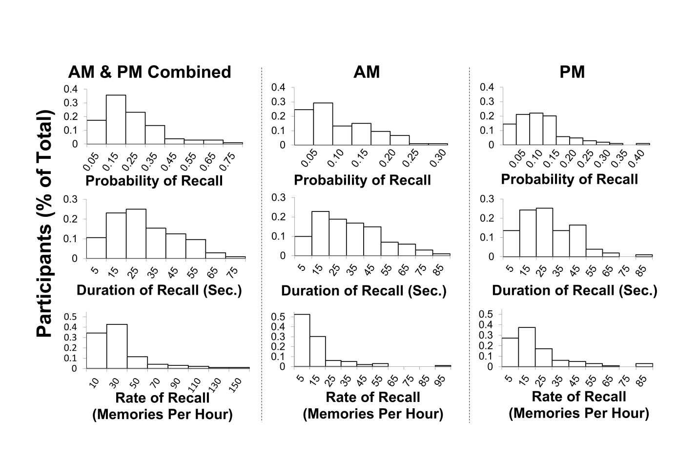
Histograms of recall probability, duration and rate of AM and PM, presented individually and combined across memory types, feature mild to moderate right-tailed distributions. Data are collapsed across age groups.

Figure S2. Self-reported measures of AM and PM.

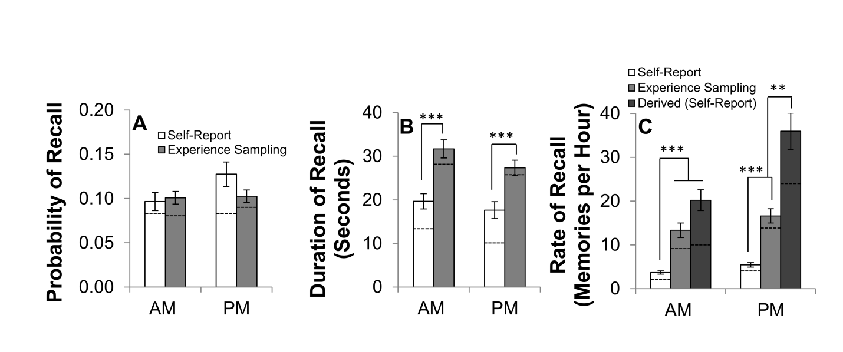
(A) Self-reported measures of the probability of AM and PM recall were equivalent to those observed by experience sampling. (B) In contrast, participants reported lower durations than those perceived naturalistically. (C) Combining self-reports of recall probability and duration, ~20 AMs and ~36 PMs should be expected to occur each hour (shown as derived MpH). Direct estimates of these values were far lower than both those calculated from experience sampling data and those derived from self-reports of recall probability and duration. Thus, while the recall rate observed in natural settings may strike as surprisingly high, this appearance may be attributed to a bias revealed by the clear inconsistency between derived and estimated MpH in the self-reports. Self-Reports: AM probability: n=98; PM probability: n=98; AM duration: n=98, PM duration: n=95; AM MpH: n=95; PM MpH: n=98; AM dMpH: n=92; PM dMpH: n=93. Experience sampling data are re-plotted from Figure S1 (younger age group) to facilitate comparison across collection methods. Data are presented as mean ± one SEM. Dashed lines indicate median values. **p < 0.01; ***p < 0.001.
Supplemental Text
Design considerations
Employing an equivalent sampling procedure as that used in the current work, we previously measured the occurrence and duration of AM in college-aged subjects (Gardner, Vogel, Mainetti & Ascoli, 2012). While the mean duration of AMs observed in the present study is consistent with that previously reported, the presently observed AM recall probability is lower (~10% vs. ~16%, d=0.68). It is unclear precisely what factor or factors contributed to the discrepancy across experiments. One glaring methodological difference is the inclusion of PM as a targeted cognitive phenomenon in the present work. It is plausible that certain memories defined as PMs (e.g., those thoughts that recalled an intention, formed in the past, to act in the future) may have been documented as AMs in the prior study (e.g., see Schlagman, Kliegel, Schulz & Kvavilashvili, 2009). Further research is needed to compare the results of these distinct designs directly, particularly when considering the variability of individual accounts employing disparate research methods of the prevalence of subjective thought (cf. Cameron, 1972; Cameron, Desai, Bahador & Dremel, 1977;; D’Argembeau, Renaud & Van der Linden, 2011; Gardner et al., 2012; Klinger & Cox, 1987; Kvavilashvili & Fisher, 2007; Rasmussen & Berntsen, 2011; Schlagman et al., 2009).
Consequently, we find it prudent to highlight and discuss several methodological choices and limitations of the current research. For instance, as in earlier reports (Gardner et al., 2012), it was up to the participant to identify and classify the mental states each prompt interrupted. To minimize the inherent subjective variability of these decisions, pre-study instruction was designed to ensure that each participant had an accurate and comparable understanding of AM, PM, and the goals of the experience sampling procedure. Post-study participant debriefs of recorded memories were in agreement with these prescribed guidelines, supporting the effectiveness of this protocol (see Methods). Moreover, given that measures of recall were equivalent within and across days of participation (Table S1), it appears that subjects were able to reliably remember and apply memory classifications to sampled moments across the experiment. PM, as targeted in the current work, included thoughts associated with goal-directed planning in addition to those which reflected future-oriented episodic musings (see Methods). Although this is a subtle distinction, and there is considerable overlap among and interactions between these types of thought, they may play distinct functional roles. Further work will help determine the individual contributions of these specific thoughts to naturalistic prospection.
Values representing recall duration and rate are in terms of subjective (perceived) time, and therefore may differ from objective accounts of recollection duration. Notably, it has been suggested that time perception may change with age (Carrasco, Bernal & Redolat, 2001; Coelho et al., 2004). However, when asked to spontaneously estimate the duration of relatively short activities (a theoretically similar task to that used in the current design), younger and older adults showed equivalent time perception (Coelho et al., 2004). Moreover, participant replication of a ten second interval revealed age differences only after task repetition (Carrasco et al., 2001). These studies leave open the possibility that age effects on subjective time might confound recall duration and rate comparisons, but average effects are likely to be mild.
Calculation of mean recall durations did not account for interruptions of recorded memories. If a memory coincided with a prompt, its estimated duration was doubled, assuming that on average a call coincided with its mid-point. In other words, this calculation assumes that a sampled memory, on average, would be engaged for the same duration following the prompt as it was preceding the prompt. As everyday distractions undoubtedly would have interrupted a proportion of these sampled thoughts following a prompted moment, to some degree our design would overestimate memory duration and underestimate memory rate. A different source of systematic error might offset this potential bias: if the intervals that participants selected to receive random prompts were conducive to recollection, measures of memory occurrence would tend to be inflated. However, any selection effect should be moderated given that the daily calling schedule was continuous, did not vary from day to day, and covered a substantial fraction of the typical waking day (see Methods).

Instructional Scripts
Autobiographical Memory (AM)
Definition: An autobiographical memory is a recollection of an episode from your personal past; a memory of something that you have personally experienced in your lifetime. This memory could be of an event that occurred from the moment you were born to the most recent second you lived. The event in the memory is typically less than 3 hours and is specific to a time and place. The actual memory of the event is typically short in time (1 to 60 seconds); it is like a Kodak moment.

Autobiographical Memory Examples:

NO (Not An) AM Example: You remember a 3 hour-long trip to your grandmother’s house. Specifically, you recall thinking how long the car ride felt.
Why Not? This memory would not be considered an AM because the memory is of an event that was 3 hours long.
YES (An) AM Example: You remember once on a 3 hour-long ride to your grandmother’s house, you saw a cow for the first time. You can see the cow again through your mind’s eye and remember what you felt (e.g., curious) and the smell of manure.
Why? This is an AM because the event that you are remembering is specific to a moment in your life. This event only lasted a few minutes. It did not stretch out over hours, days, or weeks. Also, re-experiencing the feeling and smell of the event is a sign of mental time travel, a hallmark of AMs.
---------------------------------------------------------------------------------------------------------------
YES (An) AM Example: You remember the moment your dog came home after being lost for two days. You are re-living the feeling of relief that your dog is safe and the feeling of him licking your face.
Why? This is an AM because you are re-living some portions of your event (e.g., seeing your dog come home, emotional and physical feelings). Also, this memory is of an event that happened to you personally.
NO (Not An) AM Example: You remember a story about a person that lost their dog.
Why Not? This is not an AM because it is not an event that happened to you. This is a memory of an event from someone else’s life.
---------------------------------------------------------------------------------------------------------------
NO (Not An) AM Example: You remember that last week, every time you turned your head you got a shooting pain down your spine. You can feel what this pain was like.
Why Not? This is not an AM because the event is repetitive. You have experienced this event several times in your life and are not recalling a specific instance or time.
YES (An) AM Example: You remember that last week, every time you turned your head you got a shooting pain down your spine. Specifically, you recall the first time this happened, when someone called your name and you jerked your neck to see who it was.
Why? Though this is a memory of an event that has happened several times in your past, you are remembering one specific instance. It is specific to a particular time.

Prospective Memory (PM)
Definition: A prospective memory is the recollection of a task or event that is to occur in the personal future; that is, remembering an intention to perform an action in the future. The memory can be of a future task or event seconds or decades away from the present moment. The memory must also be of personal relevance. For example, the memory of the date of an upcoming event is not a PM. However, if you are recalling the date to remember to attend the event, the thought is a PM.

Prospective Memory Examples:

NO (Not A) PM Example: You recall that your friend’s phone number is 703-999-6643.
Why Not? This is not a recollection of an action that is to happen in the personal future.
YES (A) PM Example: You left your cell phone at home and are now remembering to repeat your friend’s number in your head so you can correctly dial it when you get to another phone later in the day.
Why? You are remembering to repeat a factual piece of information with the intention to perform an action in the future.
---------------------------------------------------------------------------------------------------------------
YES (A) PM Example: You recall earlier today when you wrote yourself a note to pick up groceries on the way home from work. The note didn’t help and you forgot the groceries. As a lesson learned, you tell yourself to remember to use another method in the future, e.g., placing the note on the dashboard of your car to better remind you to stop at the store.
Why? The prospective memory is remembering to use another strategy for staying on-top of the errand.
NO (Not A) PM Example: You recall earlier today when you wrote yourself a note to pick
up groceries on the way home from work. The note didn’t help and you forgot the groceries.
Why Not? This is purely an autobiographical memory. No aspect of the future is being thought about.
---------------------------------------------------------------------------------------------------------------
NO (Not A) PM Example: You remember that you have an assignment due later in the week.
Why Not? You are just recalling a fact. You are not thinking about intentions to act in the future.
YES (A) PM Example: You remember you have an assignment due later in the week. However, you can’t start it at the present moment. You think about what you are going to do to complete the assignment when you have the time.
Why? This situation involves thinking about an intention to perform an action in the future.

Self-Report Questions
Please read the following questions and estimate your answers as best you can.

- Estimate how much time you spend experiencing autobiographical memories in one given hour.

- Estimate how much time you spend experiencing prospective memories in one given hour.

- On average, how many seconds would you say you spend recalling a single episode from your past. In other words, typically how long does one autobiographical memory last (in seconds)?

- On average, how many seconds would you say you spend recalling a single intention to act in your future. In other words, typically how long does one prospective memory last (in seconds)?

- How many autobiographical memories would you say you experience in one given hour during your waking day?

- How many prospective memories would you say you experience in one given hour during your waking day?

