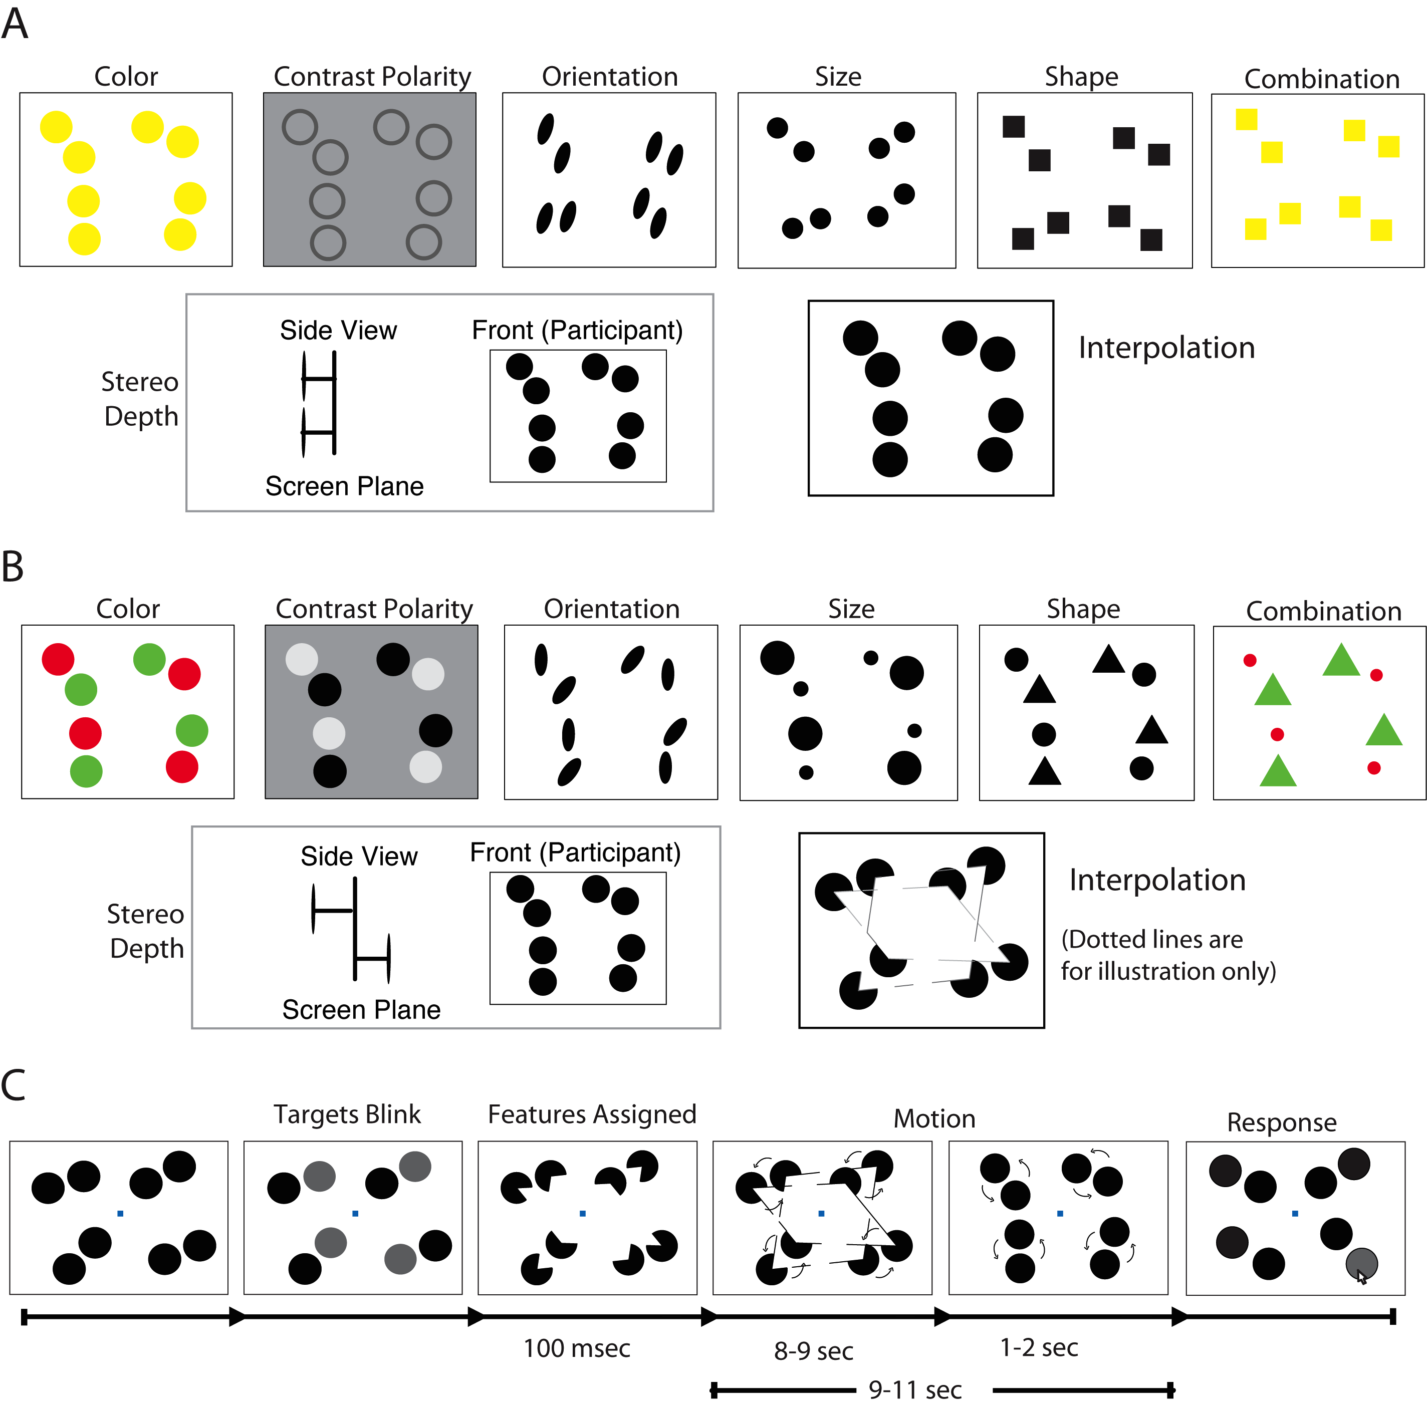
Supplementary Figure 1. Stimuli and trial sequence for Experiment 1 and 2. (A) Starting and ending appearance of objects for each feature type. At the beginning and end of a trial, objects were undifferentiated and possessed features that were different from those that appeared during the motion phase. (B) Possible screenshots of the eight feature types during the motion phase. These screenshots could derive from either the TG or the TDG grouping relations. In all cases, a quadrant contained a single target and distractor. (C) Phases of a trial for the interpolation condition. After target designation, objects (on certain conditions) became distinctive so that grouping could potentially occur. Feature changes (third panel) were instantaneous. Objects remained stationary for a brief period of time after the initial feature change. Objects orbited around a central point in each quadrant and then returned to their initial, undifferentiated states a moment before halting.

