SUPPLEMENTAL MATERIAL

Affective state influences perception by affecting decision parameters

underlying bias and sensitivity

Spencer K. Lynn, Xuan Zhang, and Lisa Feldman Barrett

Affective State Inductions
Images appeared on-screen for 5 s each (plus a 2.5 s fading transition to the next image) as music (Supplemental Table S1) played through two ceiling-mounted speakers. This combined images-with-music induction procedure was similar to those of Conklin & Perkins (2005) and Baumgartner, et al. (2006).
One hundred and eight images (36 positive, 36 negative and 36 neutral) and were selected for each movie from the IAPS (Lang, Bradley, & Cuthbert, 2005) with additional images gleaned from online images. We collected normative valence and arousal ratings (Lang, et al., 2005) for the online images in a pilot study with separate participants. The 36 images chosen for the pleasant induction comprised pictures of babies, animals, and fun activities, with an overall mean valence = 7.6 and arousal = 5.2 (these ratings of the normative ratings of the images, from IAPS and our pilot study, not the subjective affect ratings as felt by our participants). The 36 images chosen for the unpleasant induction comprised scenes of mutilations, deaths, violence, and bloody injuries (mean valence = 1.5, arousal =7.2). The 36 neutral images chosen for the neutral induction comprised images of appliances, buildings, and mushrooms (mean valence = 4.9, arousal =3.2). The music was faded in at the beginning and faded out at the end of the induction.

Supplemental Table S1. Music selections used to accompany affect induction slide shows.
State Composer Selection
Pleasant affect induction
Copland Appalachian Spring
Vivaldi The 4 Seasons Op. 8/1, "Spring" 1. Allegro
Civil Horn Concerto in E flat
Holst The Planets, Op. 32 - 4. Jupiter, The Bringer Of Jollity
Chopin Fantaisie-impromptu
Rossini William Tell Overture
Verdi Aida Grand March
Bizet L' Arlésienne, Suite #2 Farandole
Bach Brandenberg Concerto #3 in G, BWV 1048 Allegro
Mozart Eine Kleine Nachtmusik, KV 525 4.Rondo-Allegro
Handel Arrival of The Queen of Sheba
Williams The Wasps
Vivaldi Mandolin Concerto in C major

Supplemental Table S1, continued.
State Composer Selection
Unpleasant affect induction
Penderecki Threnody for the Victims of Hiroshima
Bartok The Miraculous Mandarin
Prokofiev Battle on the Ice
Verdi Dies Irae, Dies Illa
Neutral affect induction
Adams Common Tones in Simple Time
Fripp Wind on water
Sakamoto Soundbytes

We instructed the participants to: "Immerse yourself and focus intensely on each picture.", "Feel free to use your imagination to make the pictures more personal.", and "Allow the mood of the music and pictures to carry you.".
The unpleasant and neutral inductions were particularly effective at altering participants affective state (Supplemental Figure S1). Arousal and valence both differed significantly before vs. after the "booster" affect induction (arousal time point x induction interaction: F(2,212)=8.4, p<0.002; valence time point x induction interaction: F(2,212)=105.2, p<0.001), resulting in reasonable variability across the range of the rating scales (Supplemental Figure S2).
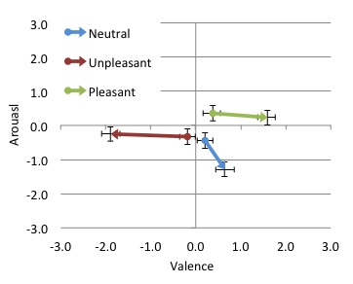
Supplemental Figure S1. Mean valence and arousal before and after the "booster" affective state induction. Error bars indicate ± 1 SD. Valence and arousal were rated by participants as integers from 1-9. For plotting, we shifted the values to range from -4 to +4.

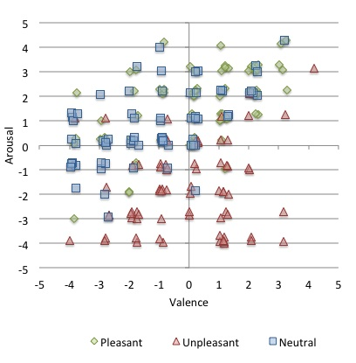
Supplemental Figure S2. Scatterplot of each participant's subjective valence and arousal, following the "booster" affective state induction. Valence and arousal were rated by participants as integers from 1-9. For plotting, we shifted the values to range from -4 to +4 and applied a random jitter to create a cloud of individual ratings around each integer value.

The Signal Detection Theory Utility Function
Signal Utility Estimator (SUE) is based on the Signal Detection Theory Utility Function (Equation 1.14 of Green & Swets [1966]), which specifies three signal parameters: similarity of target and foil signal distributions, relative base rate of target occurrence, and payoffs (see main text; Figure 1). Together, these three parameters define a perceptual decision-making environment (Lynn, Cnaani, & Papaj, 2005). The function computes the utility expected to result from placing a threshold (decision criterion) at all possible positions on the sensory domain (x-axis of Figure 1). The signal value yielding maximum utility locates the optimal placement for a decision criterion on the stimulus domain.

Following Wiley's (1994) nomenclature, the function is written as:
U(x) = α h P[CD] + α m P[MD] + (1 – α) a P[FA] + (1 – α) j P[CR]
where:
U(x) = estimated utility over the stimulus domain, x;
Similarity Parameter
P[CD] = probability of correct detection, measured as the integral of the Target distribution from threshold to infinity;
P[MD] = probability of missed detection, equal to 1-P[CD];
P[FA] = probability of false alarm, measured as the integral of the Foil distribution from threshold to infinity;
P[CR] = probability of correct rejection, equal to 1-P[FA];
Base rate Parameter
α = alpha, the base rate or relative probability of encountering a Target signal; 1–α equals the relative probability of encountering a signal from the Foil distribution;
Payoff Parameter
h = benefit of correct detection;
m = cost of missed detection;
a = cost of false alarm; and
j = benefit of correct rejection. Costs might be negative or simply less positive than benefits, as long as h>m and j>a.

The Line of Optimal Response (LOR)
In environments that engender a non-neutral bias, the Line of Optimal Response (LOR) shows an inverse relationship between bias and sensitivity (Supplemental Figure S3). The LOR represents the amount of bias that optimizes perceptual decision-making at different levels of perceptual similarity while the base rate and payoff remain constant. We measured optimality of bias as the shortest Euclidian distance from a point defined by a perceiver's observed sensitivity and bias to the LOR. Shorter distance-to-LOR, d_{O}, reflects a more optimal bias; at a given level of sensitivity, perceivers whose bias places them closer to the LOR make more effective perceptual decisions (measured by, e.g., net points earned over a series of decisions).
We determined the LOR (separately for each test condition) by mathematical modeling of the utility estimated to accrue from all possible combinations of bias and sensitivity for given constant values of payoff and base rate. To instantiate variability in the amount of perceptual uncertainty, the standard deviations of Gaussian target and foil signal distributions were varied together from 0.5 (creating high sensitivity) to 20 (creating low sensitivity). Each standard deviation level produced a unique utility function. For each of the resulting utility functions, estimated sensitivity (d') and bias (c) were calculated (Macmillan & Creelman, 1991) for decision criteria at each point on the utility function. These calculations produced a matrix of utility values associated with possible combinations of sensitivity and bias for the given static base rate and payoff values. Identifying the bias that resulted in maximum utility at each sensitivity level yielded the LOR. Modeling was programmed in Matlab (version 2009a, The Mathworks, Inc).

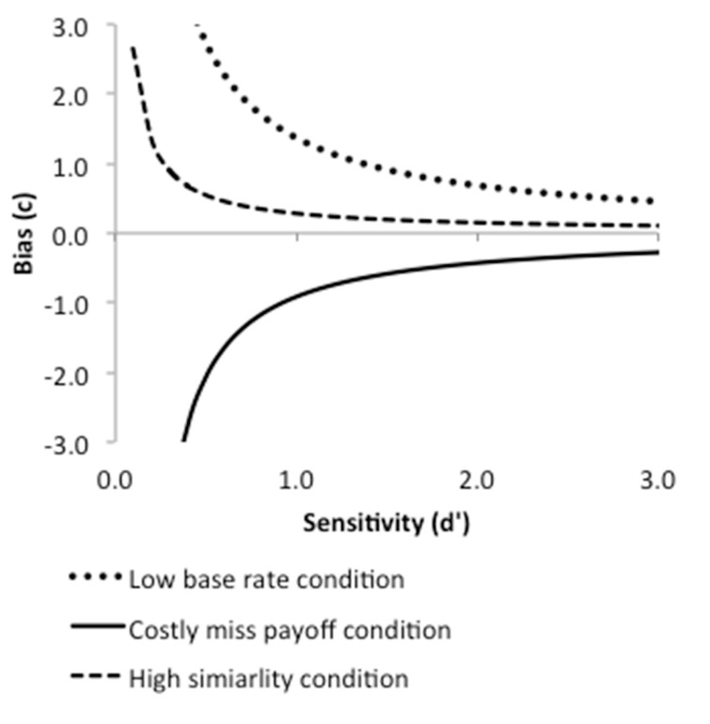
Supplemental Figure S3. Lines of Optimal Response (LOR). For given values of base rate and payoff, there is an amount of bias that will maximize utility at any level of sensitivity. The LOR identifies that bias. For example, in conservatively biased environments, such as the low base rate and high similarity conditions, the worse perceivers' ability to distinguish the "more" from "less" threatening faces (the lower their sensitivity) the less willing they should be to attribute threat to their perceptions (the greater their bias). As well, at a given level of sensitivity, perceivers whose level of bias places them farther from the LOR will accrue less utility over a series of decisions than perceivers closer to the LOR.
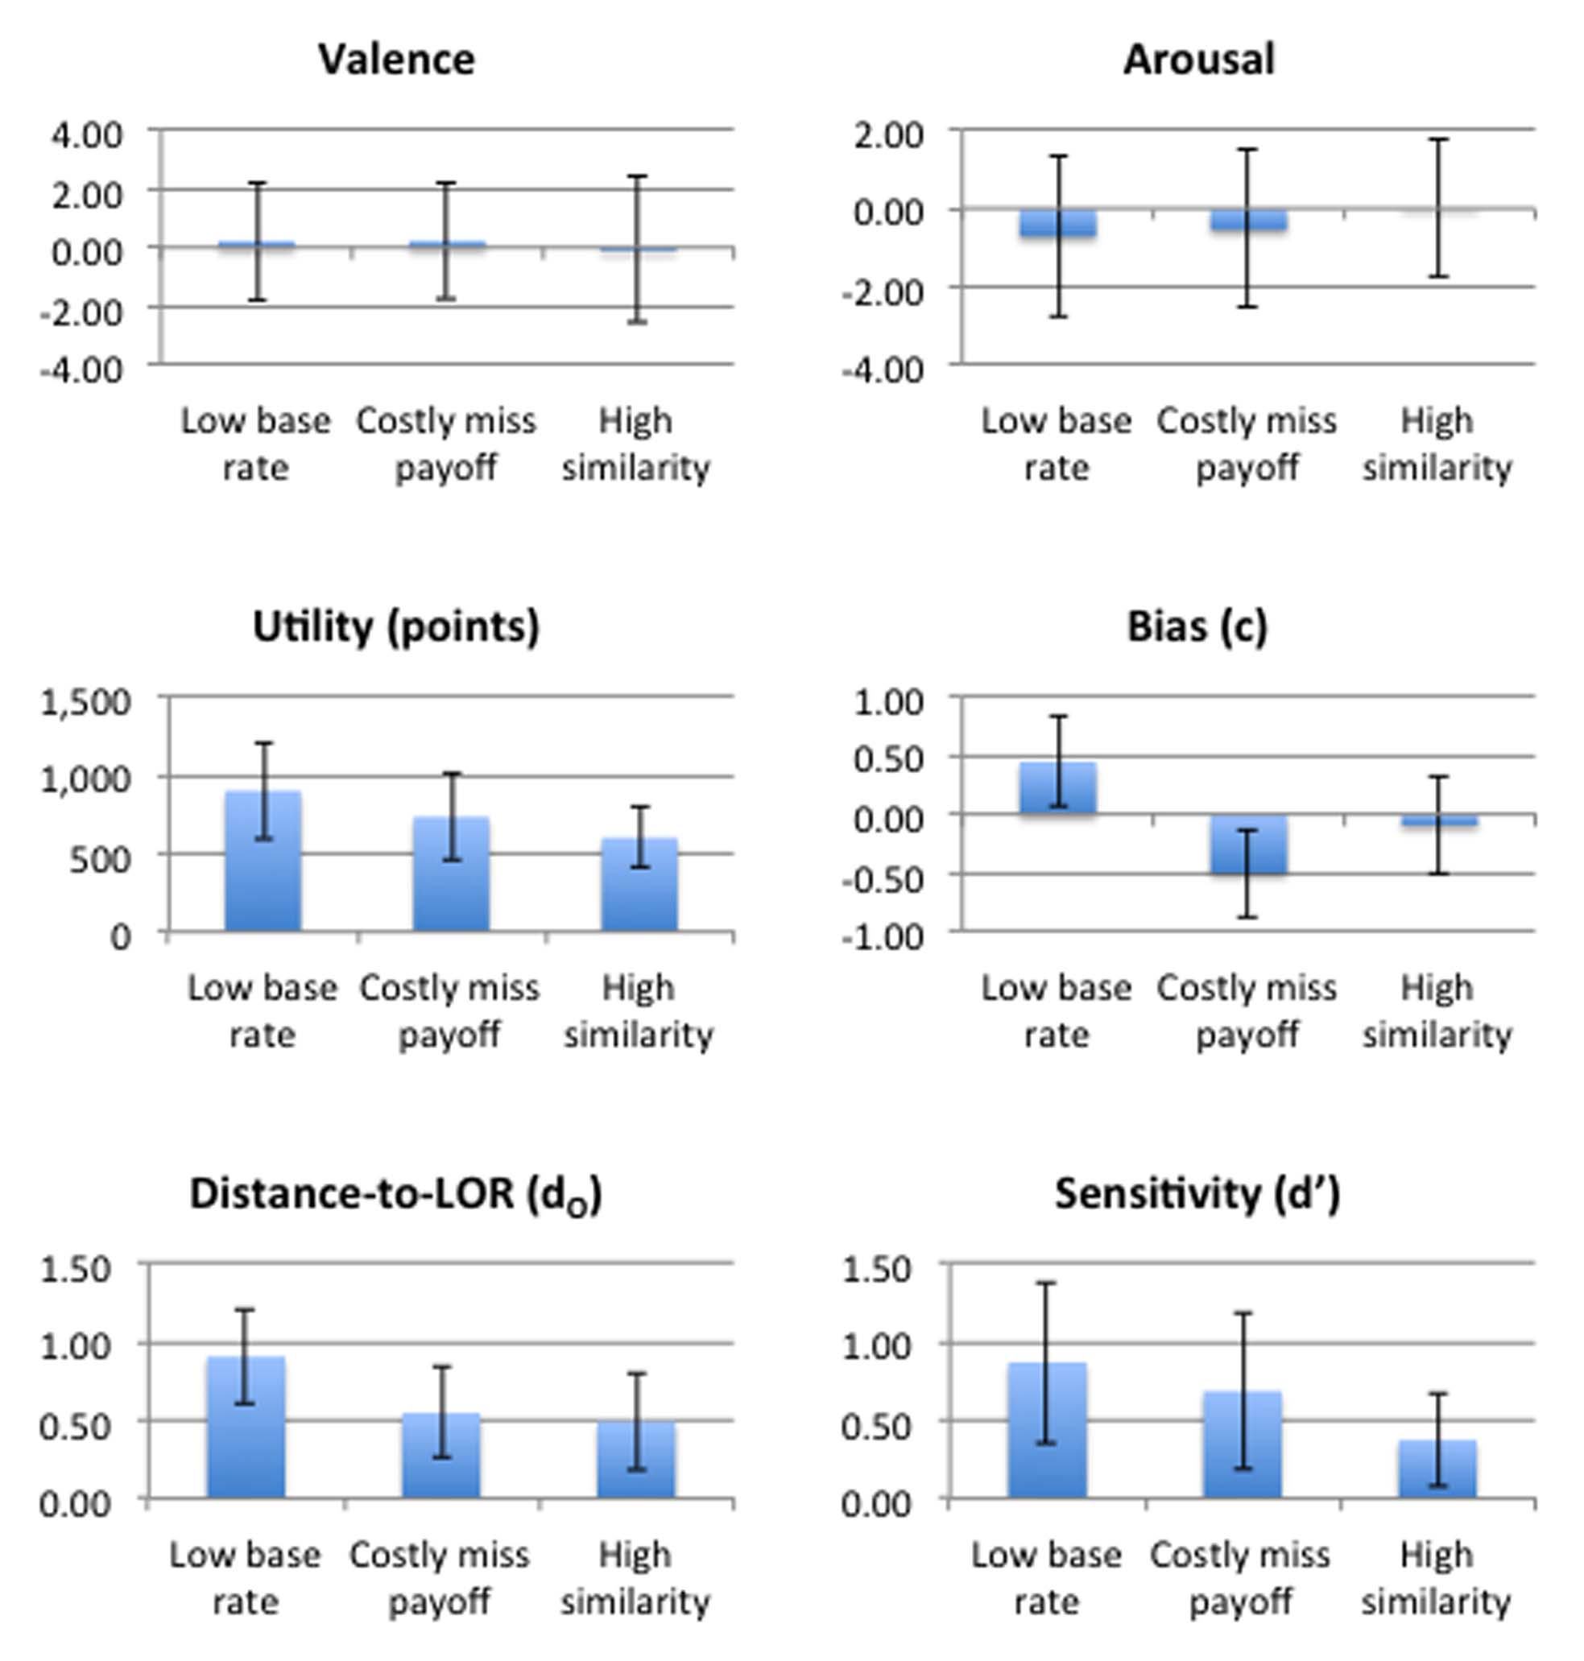
Supplemental Figure S2. Mean valence, arousal, points earned, bias, distance-to-LOR, and sensitivity among the three perceptual environment test conditions. Error bars indicate ± 1 SD.
References for Supplemental Material
Baumgartner, T, Esslen, M, & Jäncke, L (2006). From emotion perception to emotion experience: Emotions evoked by pictures and classical music. International Journal of Psychophysiology, 60, 34-43.
Conklin, C, & Perkins, K (2005). Subjective and reinforcing effects of smoking during negative mood induction. Journal of abnormal psychology, 114, 153-164.
Green, DM, & Swets, JA (1966). Signal detection theory and psychophysics. New York: Wiley.
Lang, PJ, Bradley, MM, & Cuthbert, BN (2005). International affective picture system (IAPS): Affective ratings of pictures and instruction manual. Technical report A-6. Gainesville, FL: University of Florida.
Lynn, SK, Cnaani, J, & Papaj, DR (2005). Peak shift discrimination learning as a mechanism of signal evolution. Evolution, 59, 1300-1305.
Macmillan, NA, & Creelman, CD (1991). Detection theory: A user's guide. New York: Cambridge University Press.
Wiley, RH (1994). Errors, exaggeration, and deception in animal communication. In L. A. Real (Ed.), Behavioral mechanisms in evolutionary ecology (pp. 157-189). Chicago: University of Chicago Press.

